**CLASSROOMS**

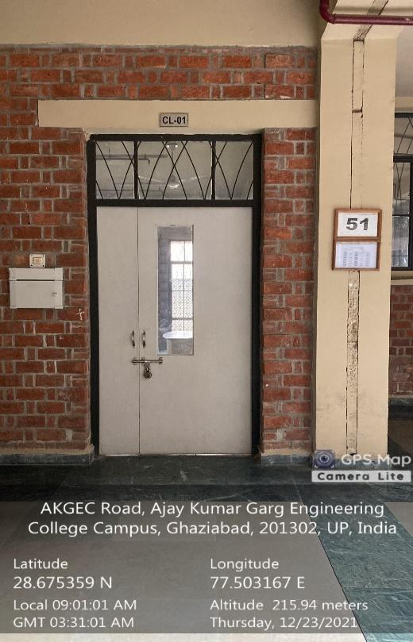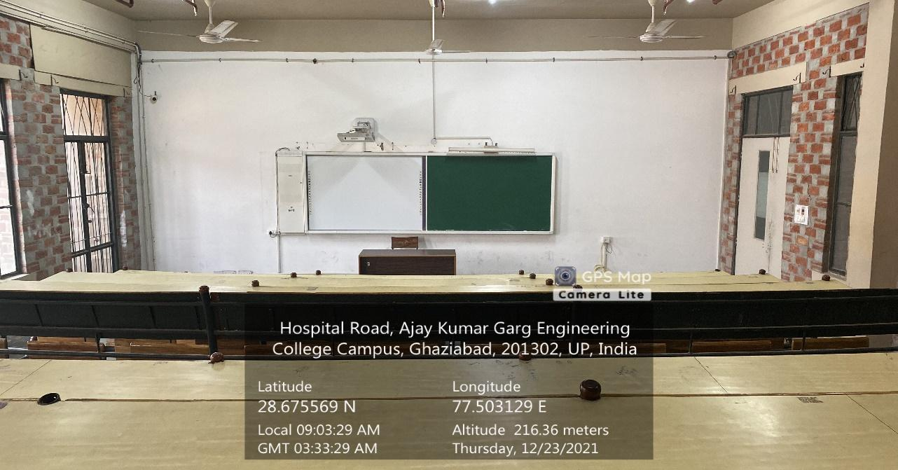

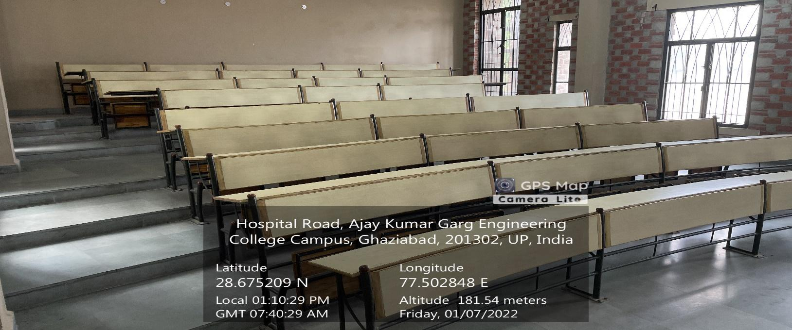

**CL-01**

**(CS&IT BLOCK, GROUND FLOOR)**

**(Available Facilities: Green Board, Smart Board Wi-Fi, Sound System)**

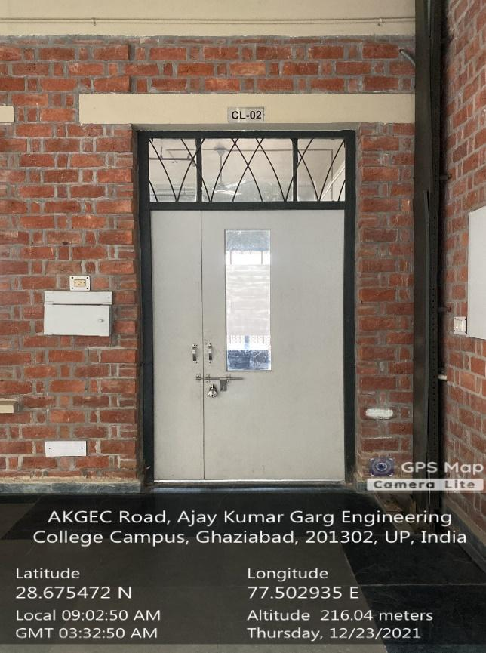 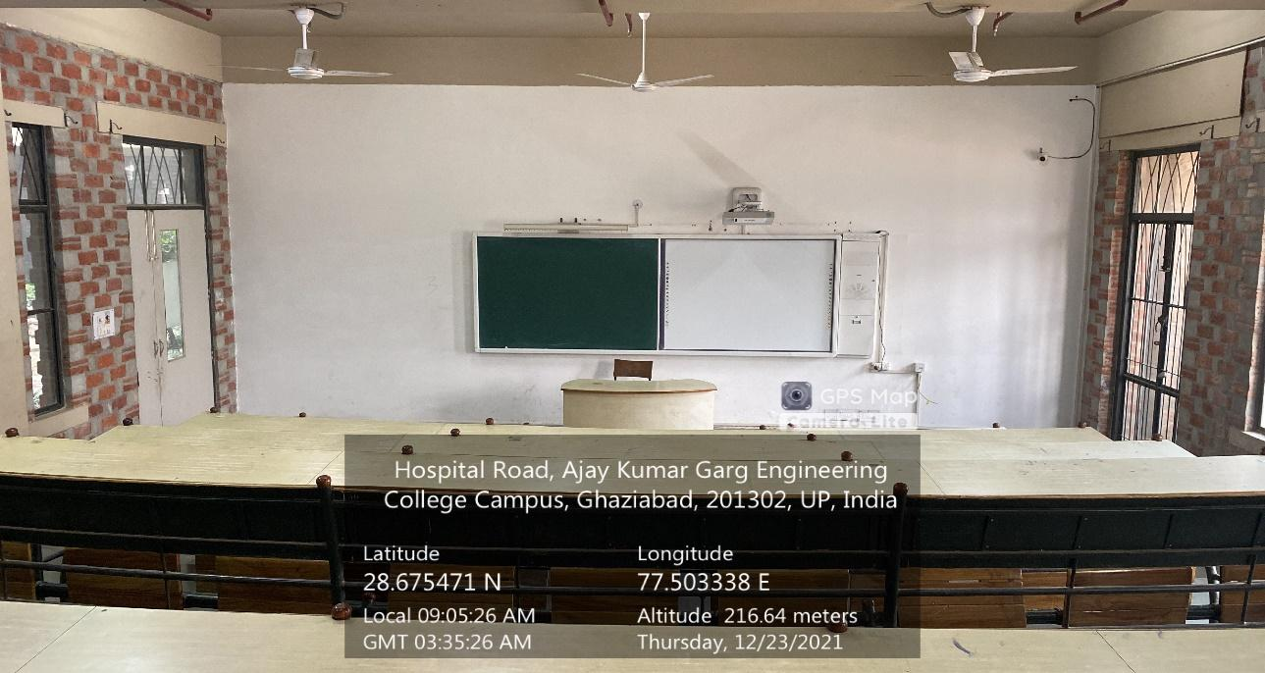

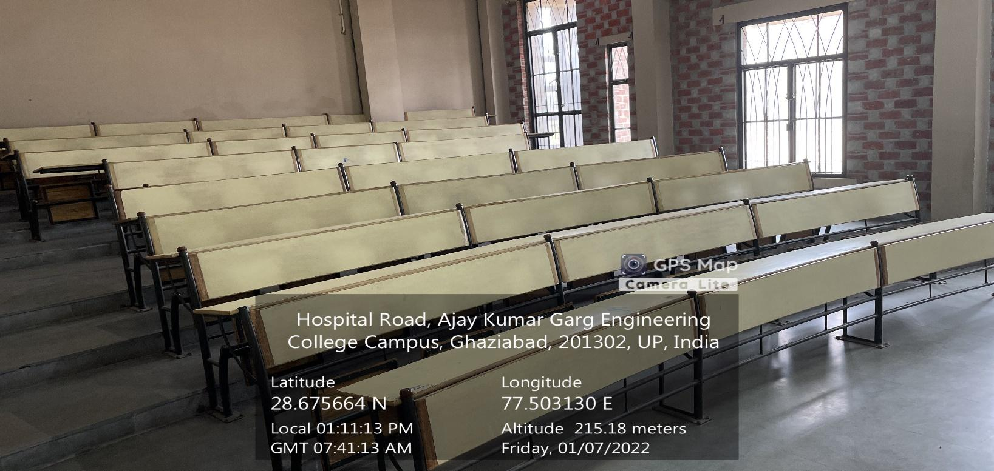**CL-02**

**(CS&IT BLOCK, GROUND FLOOR)**

**(Available Facilities: Green Board, Smart Board, Wi-Fi, Sound System)**

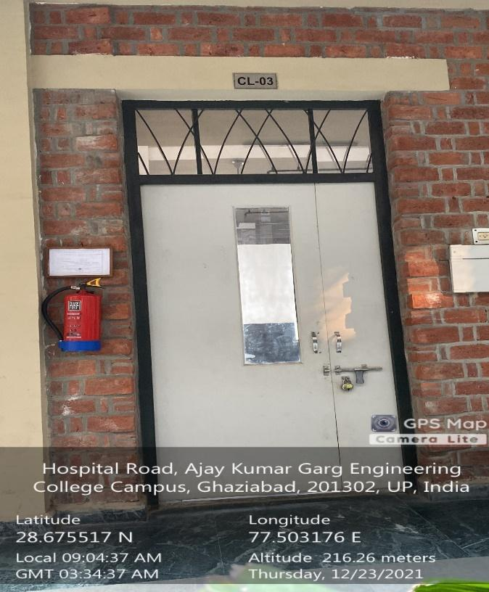 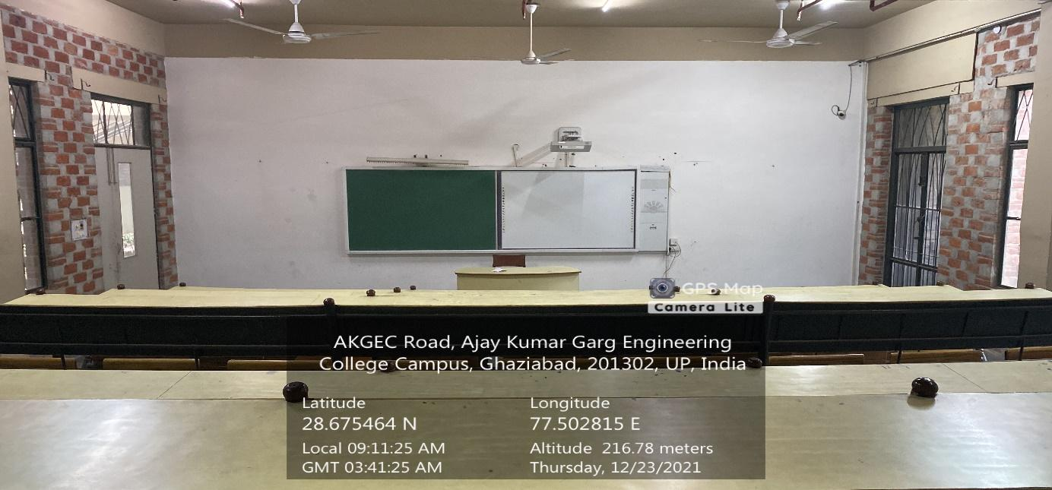

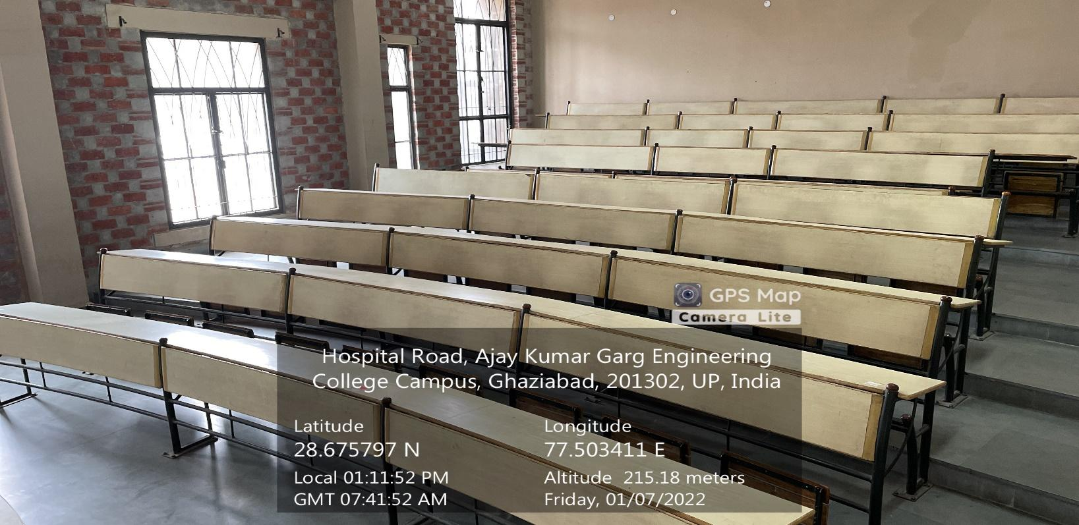

**CL-03**

**(CS&IT BLOCK, GROUND FLOOR)**

**(Available Facilities: Green Board, Smart board, Wi-Fi, Sound System)**

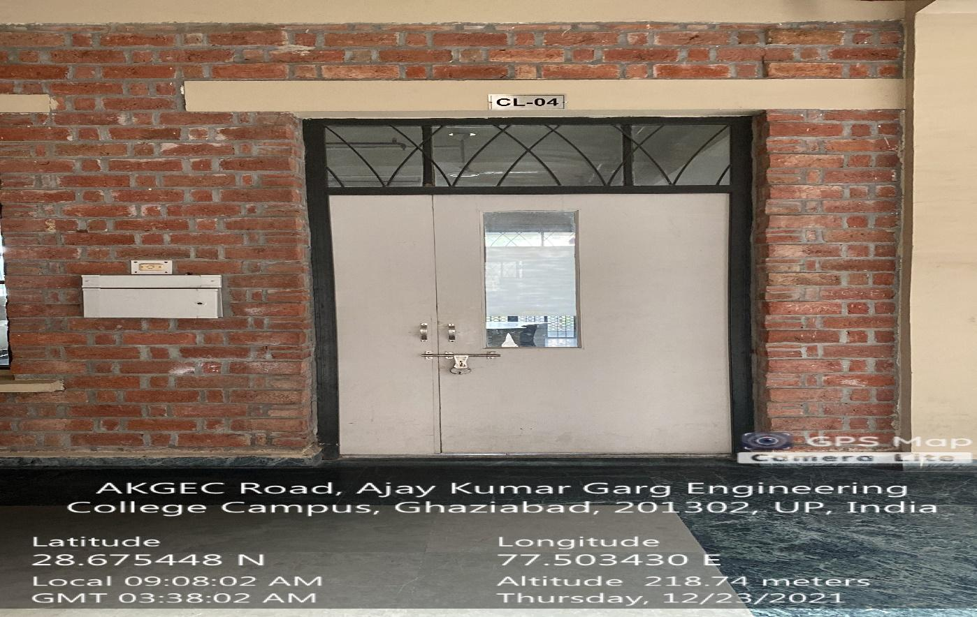 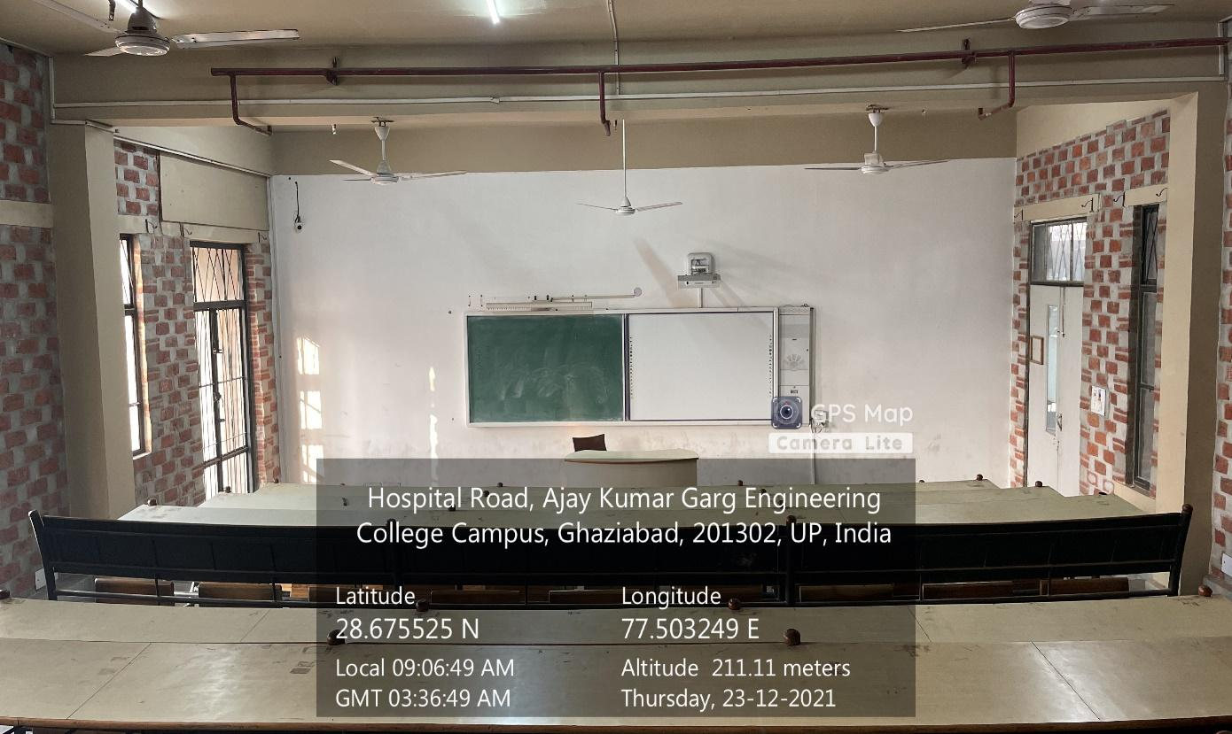

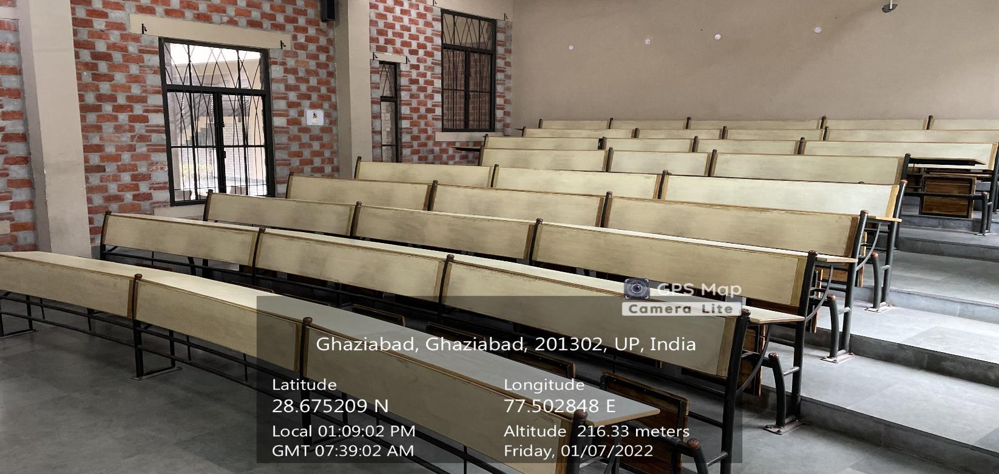

**CL-04**

**(CS&IT BLOCK, GROUND FLOOR)**

**(Available Facilities: Green Board, Smart board, Wi-Fi, Sound System)**

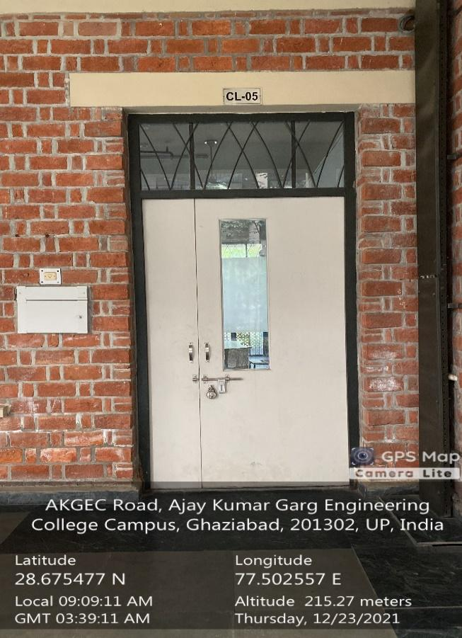 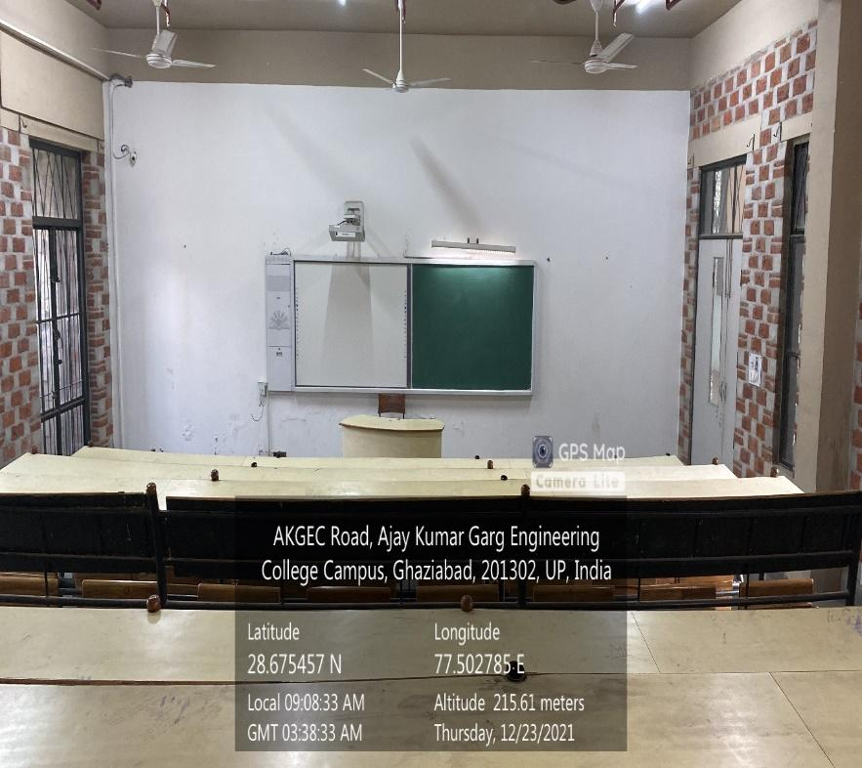

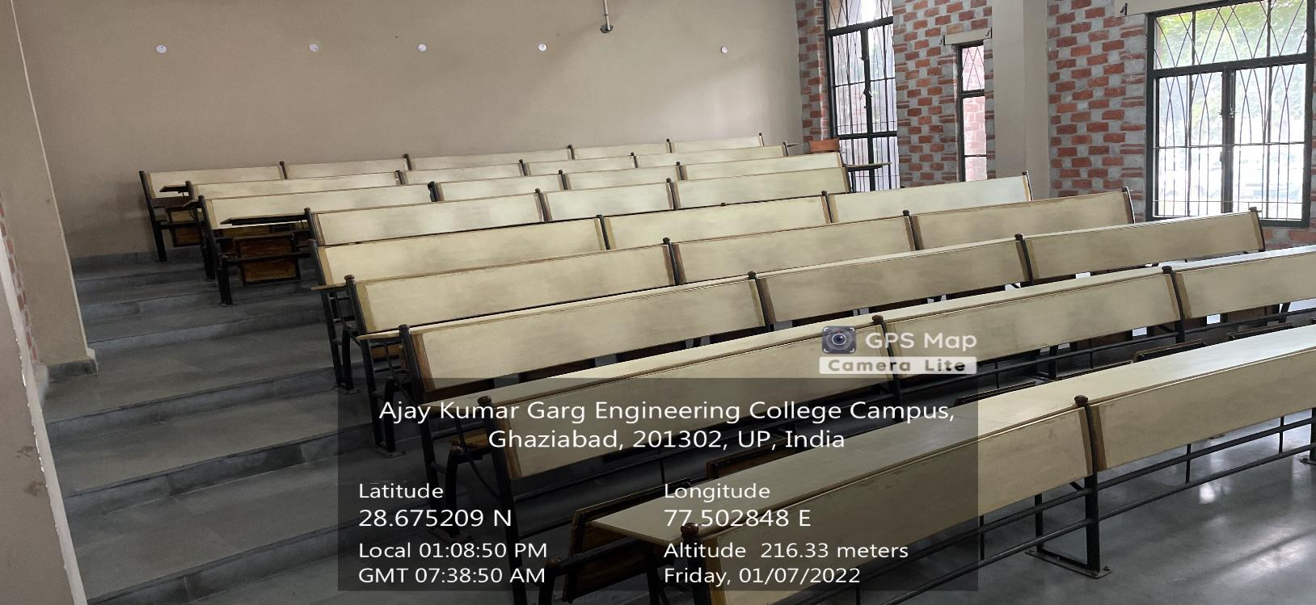**CL-05**

**(CS&IT BLOCK, GROUND FLOOR)**

**(Available Facilities: Green Board, Smart board, Wi-Fi, Sound System)**

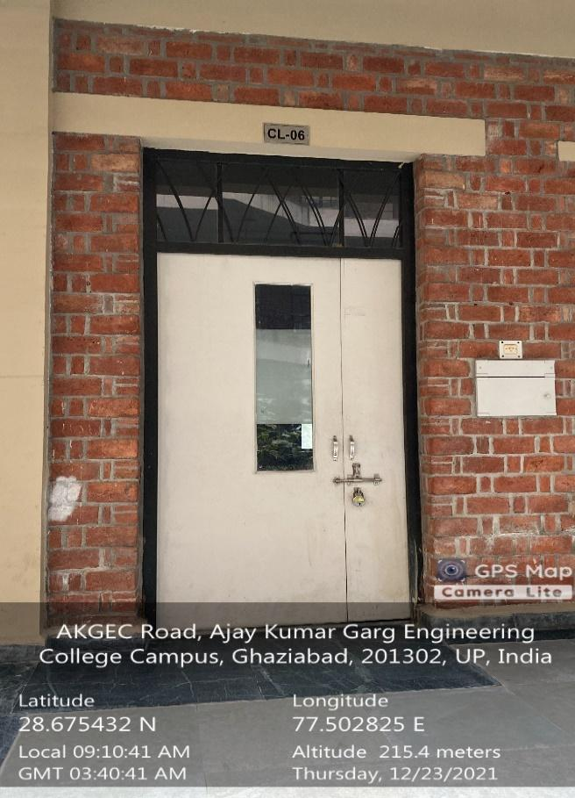 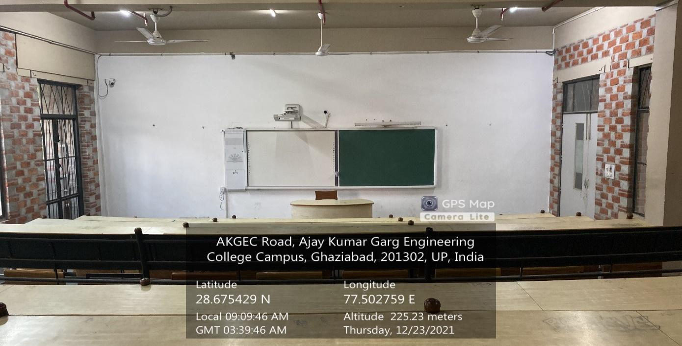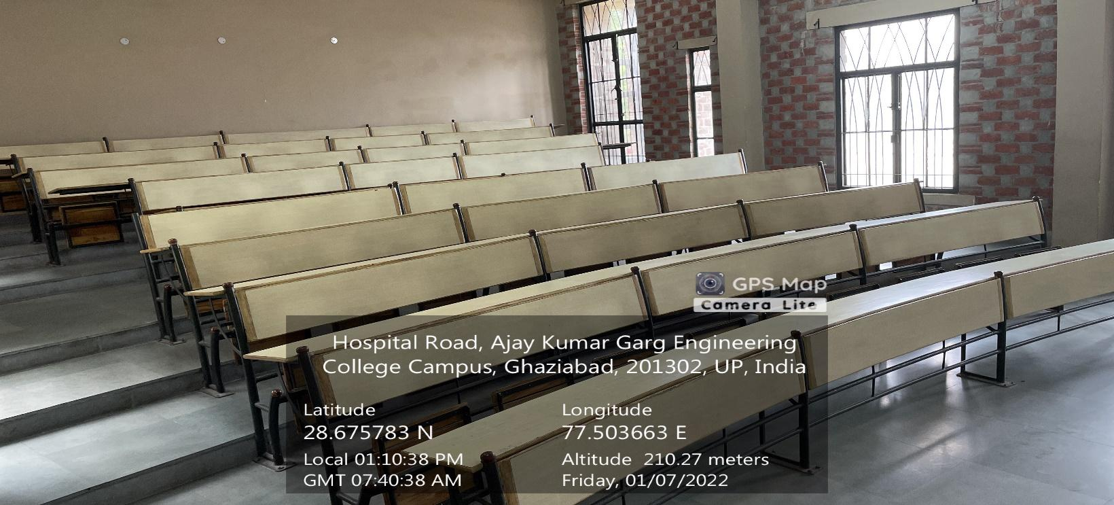**CL-06**

**(CS&IT BLOCK, GROUND FLOOR)**

**(Available Facilities: Green Board, Smart board, Wi-Fi, Sound System)**

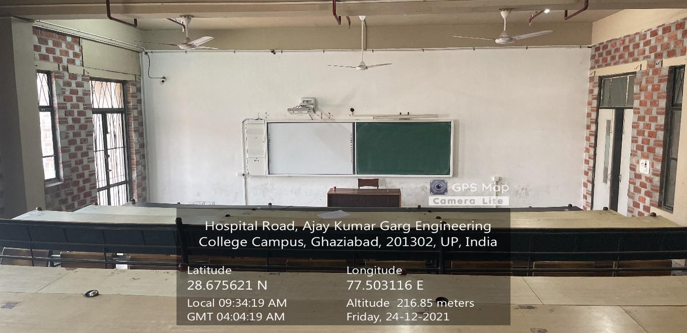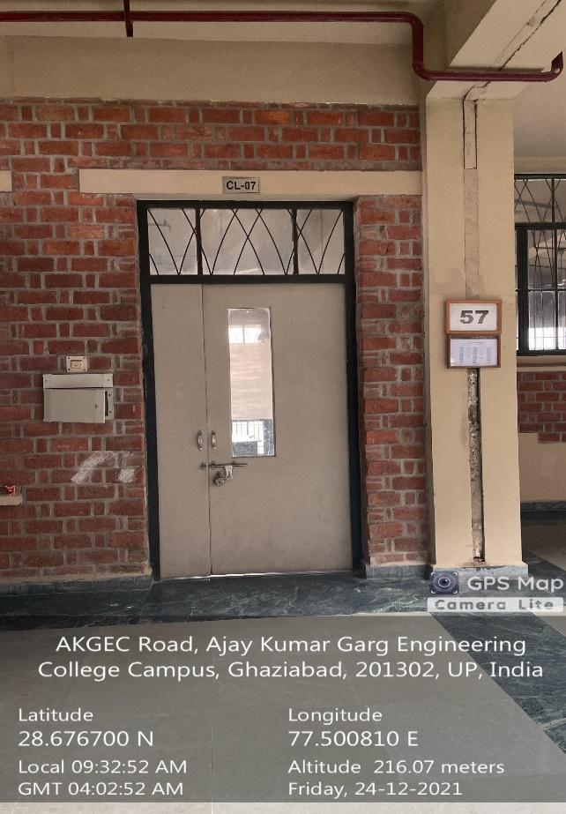

**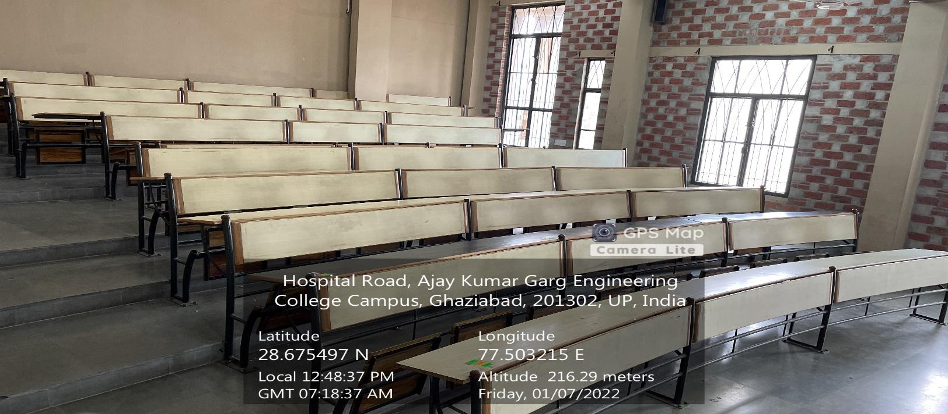  
CL-07**

**(CS&IT BLOCK, FIRST FLOOR)**

**(Available Facilities: Green Board, Smart board, Wi-Fi, Sound System)**

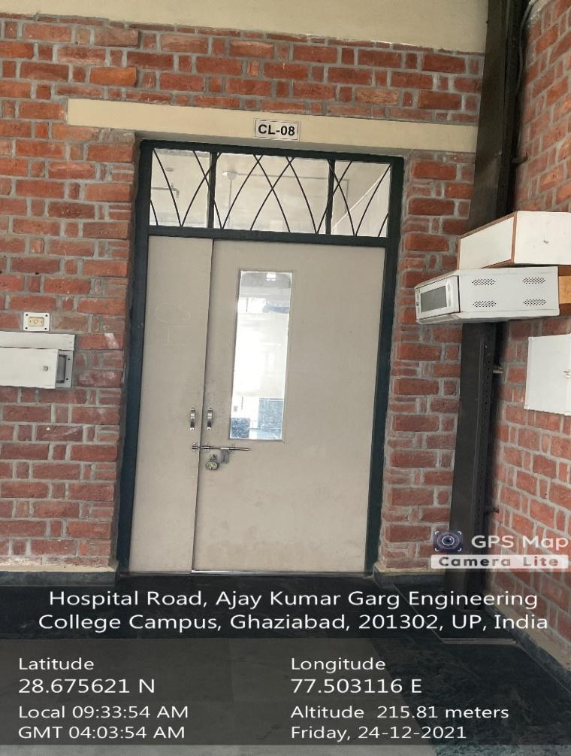 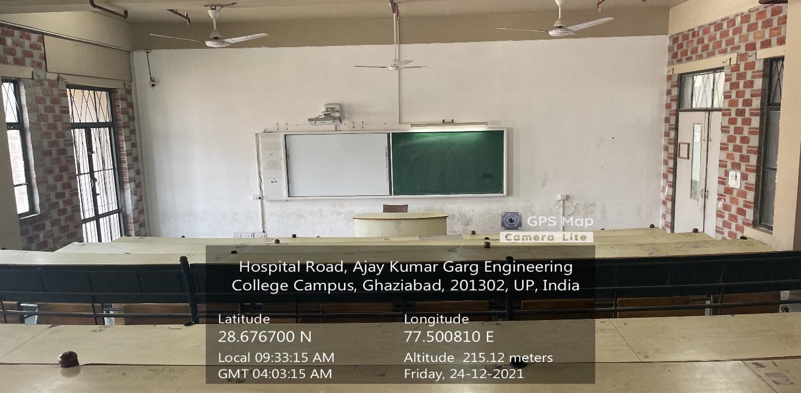

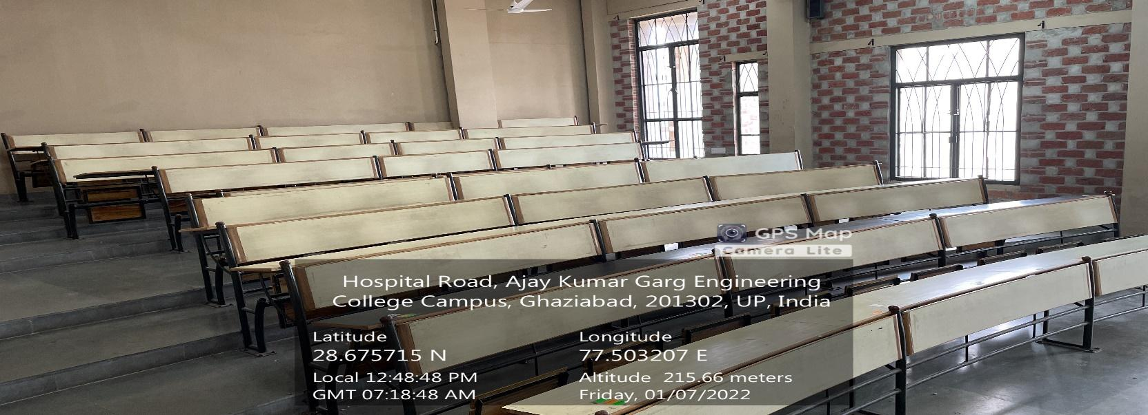

**CL-08**

**(CS&IT BLOCK, FIRST FLOOR)**

**(Available Facilities: Green Board, Smart board, Wi-Fi, Sound System)**

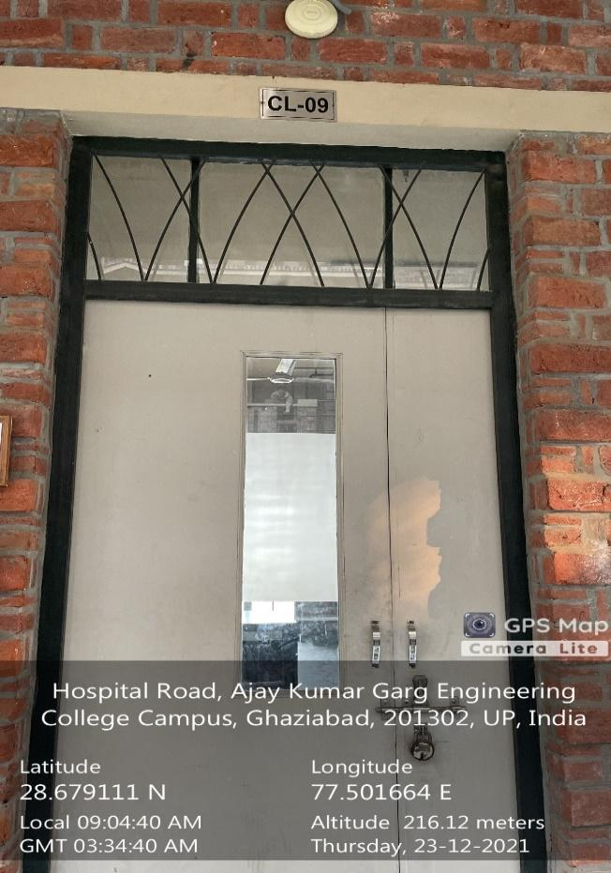 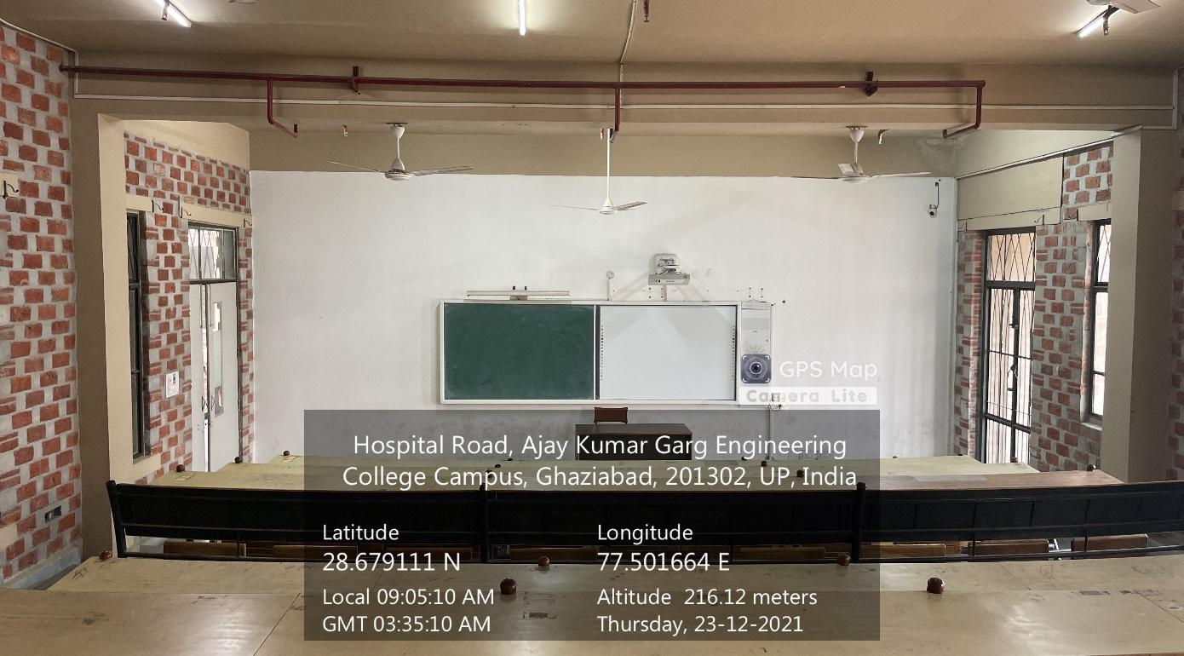

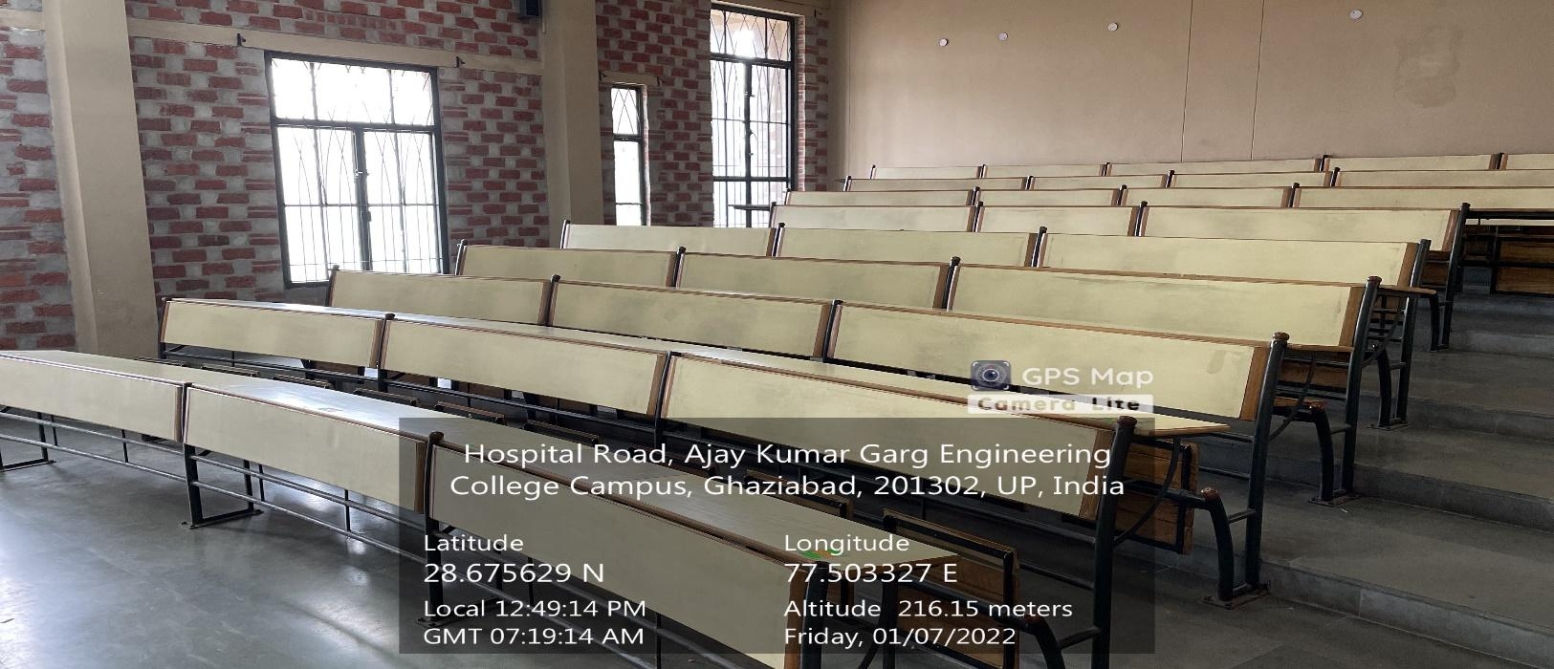**CL-09**

**(CS&IT BLOCK, FIRST FLOOR)**

**(Available Facilities: Green Board, Smart board, Wi-Fi, Sound System)**

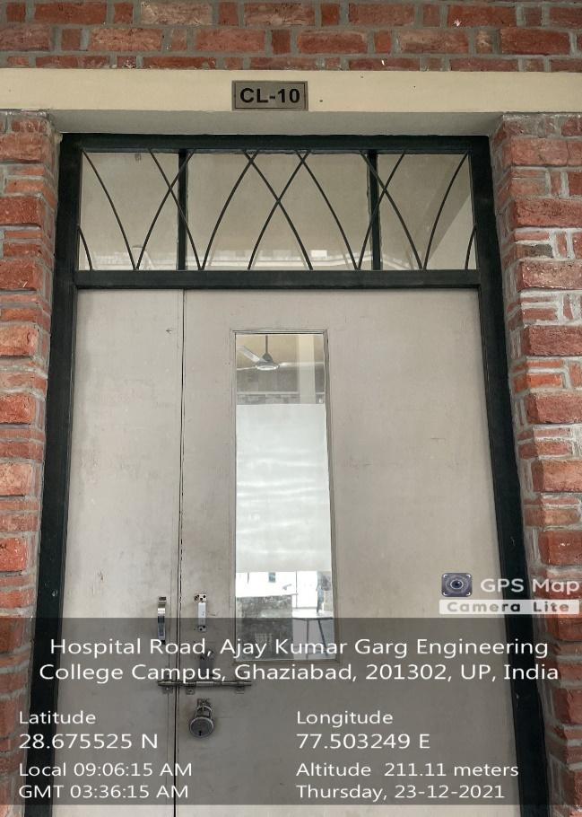 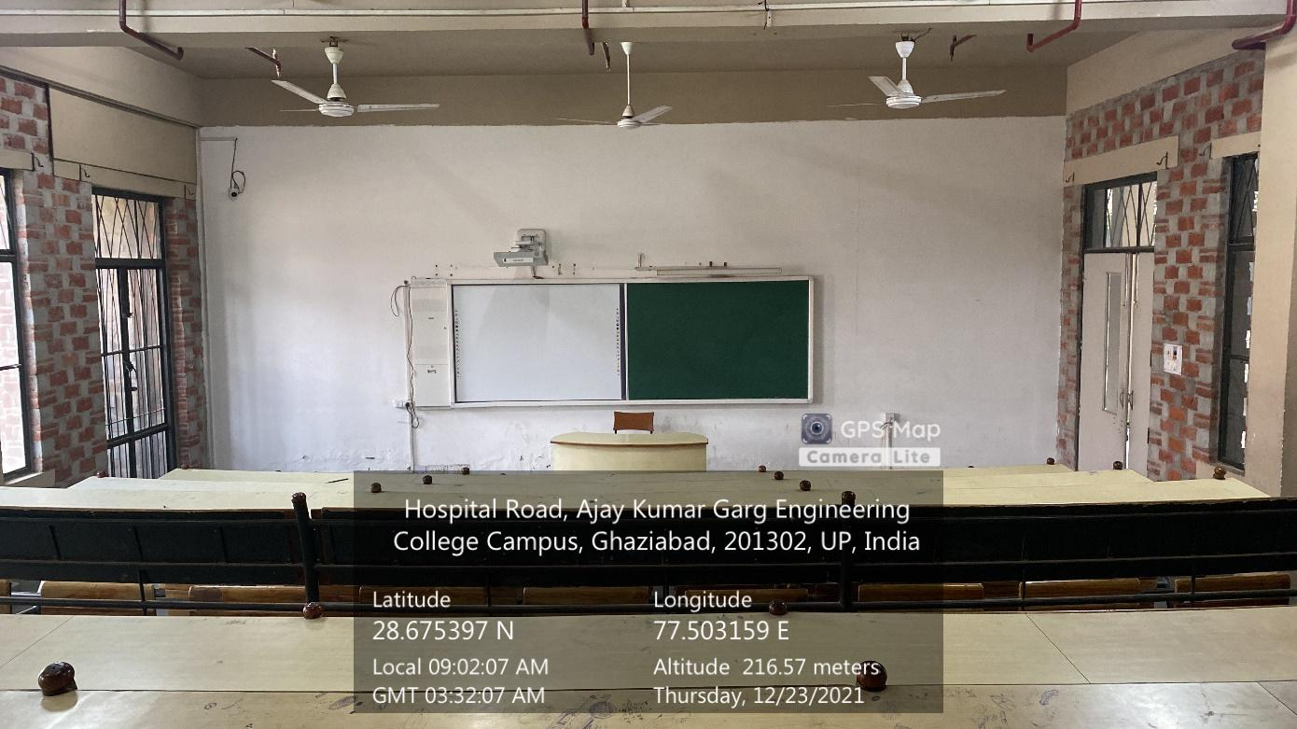

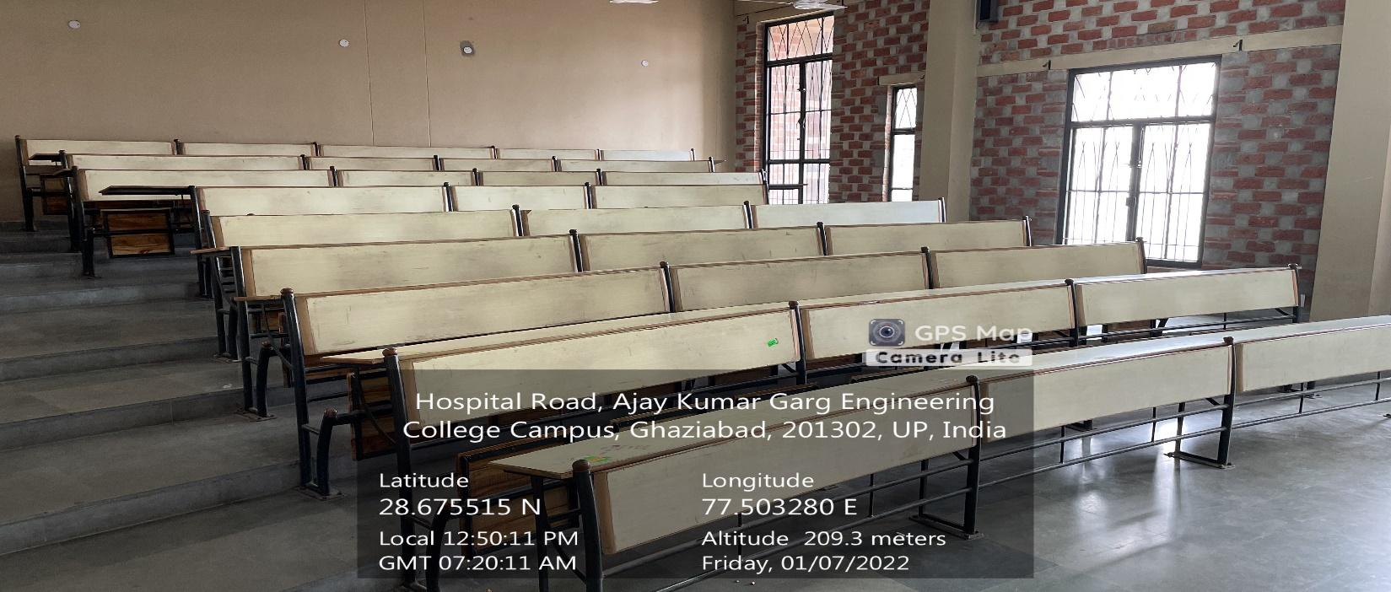

**CL-10**

**(CS&IT BLOCK, FIRST FLOOR)**

**(Available Facilities: Green Board, Smart board, Wi-Fi, Sound System)**

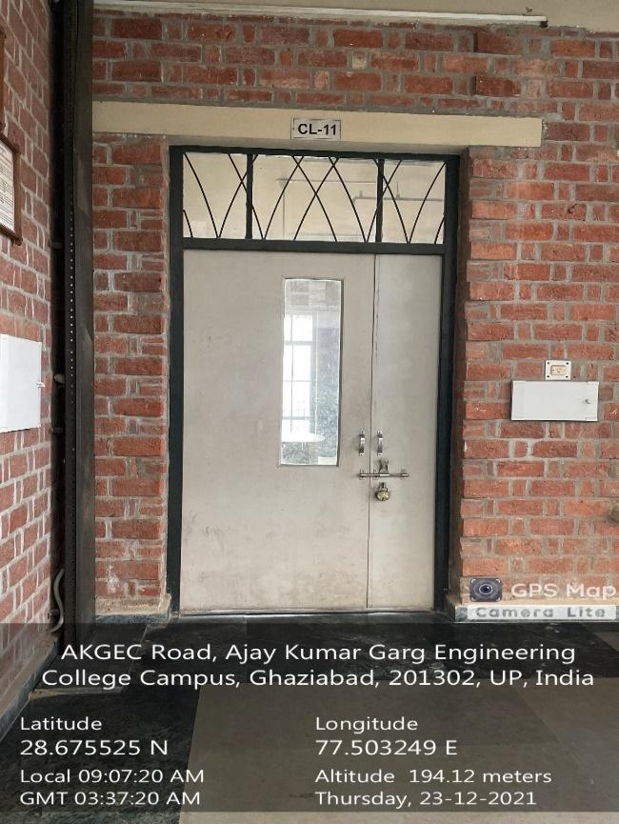 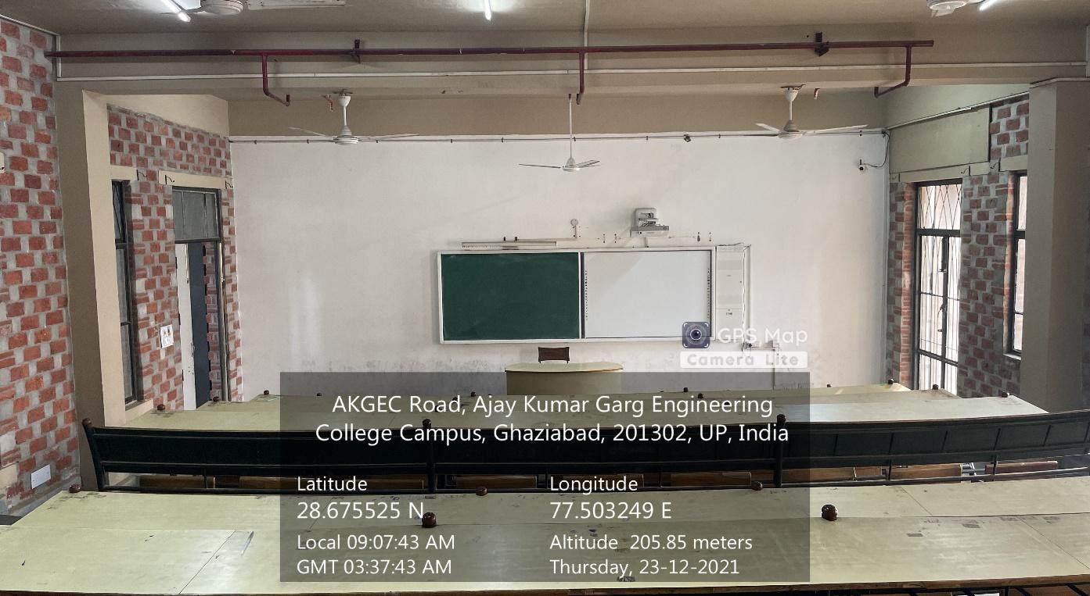

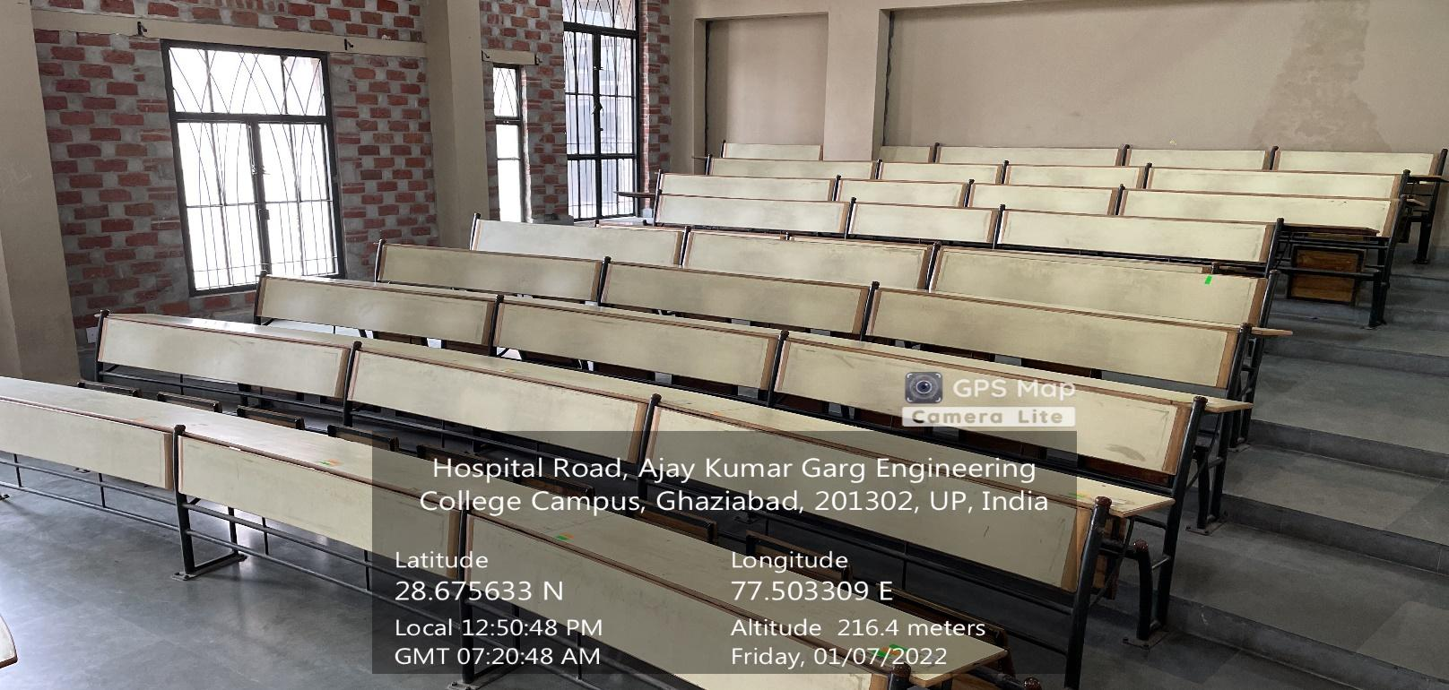**CL-11**

**(CS&IT BLOCK, FIRST FLOOR)**

**(Available Facilities: Green Board, Smart board, Wi-Fi, Sound System)**

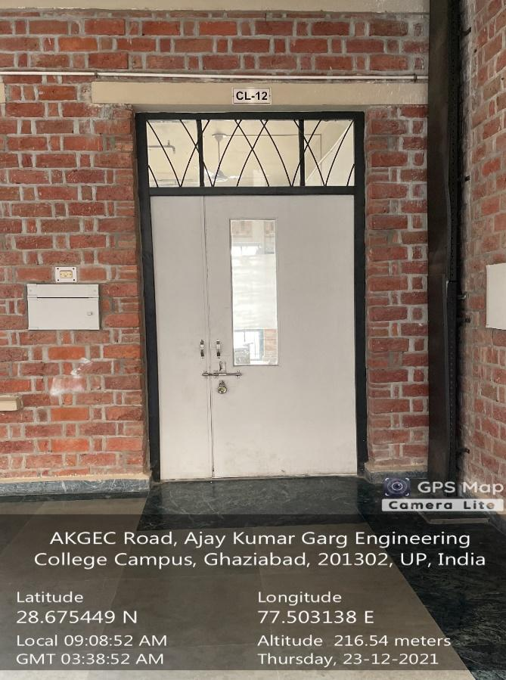 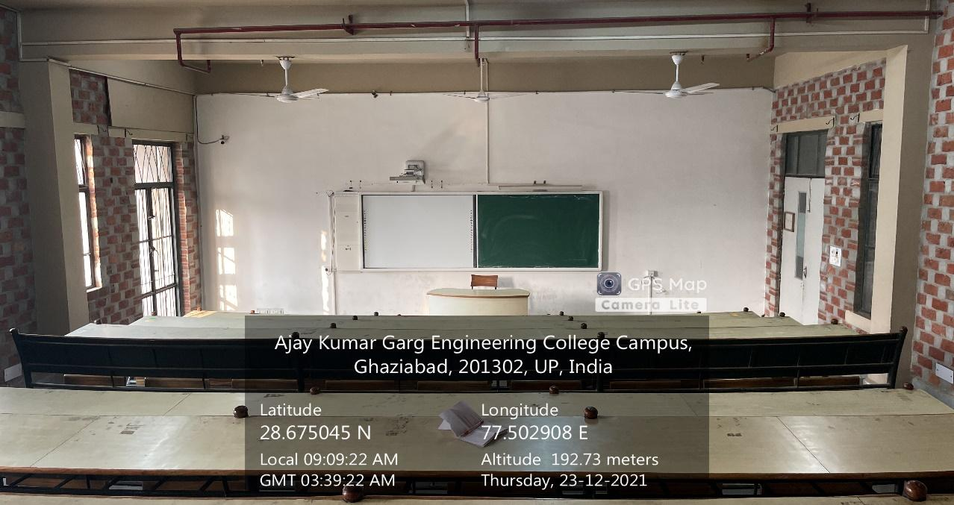

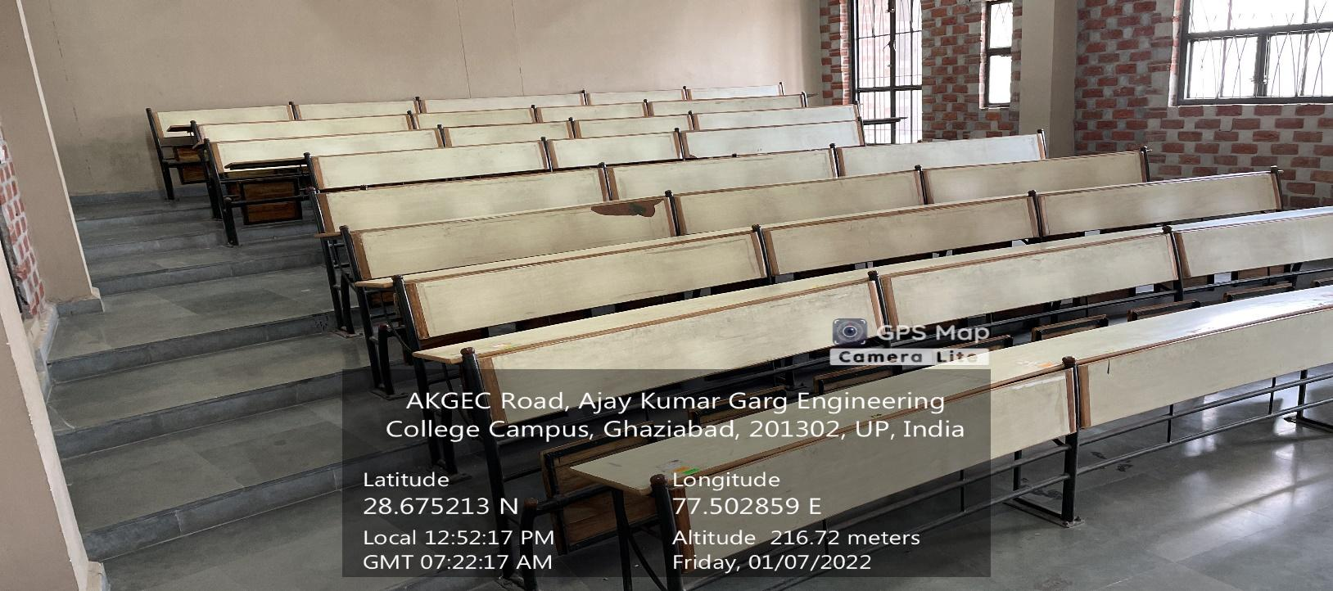**CL-12**

**(CS&IT BLOCK, FIRST FLOOR)**

**(Available Facilities: Green Board, Smart board, Wi-Fi, Sound System)**

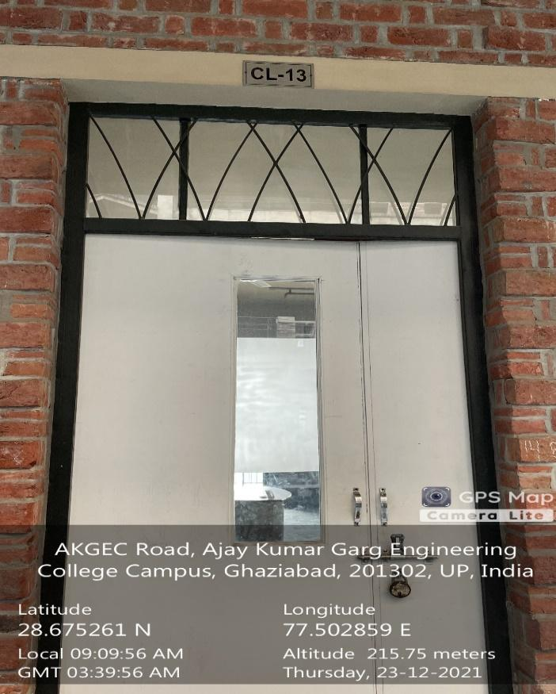 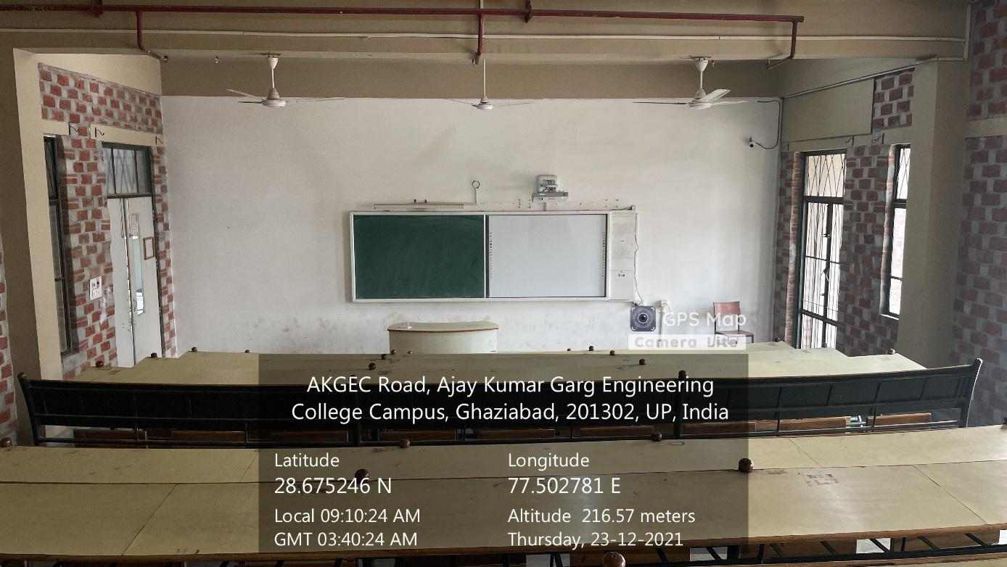

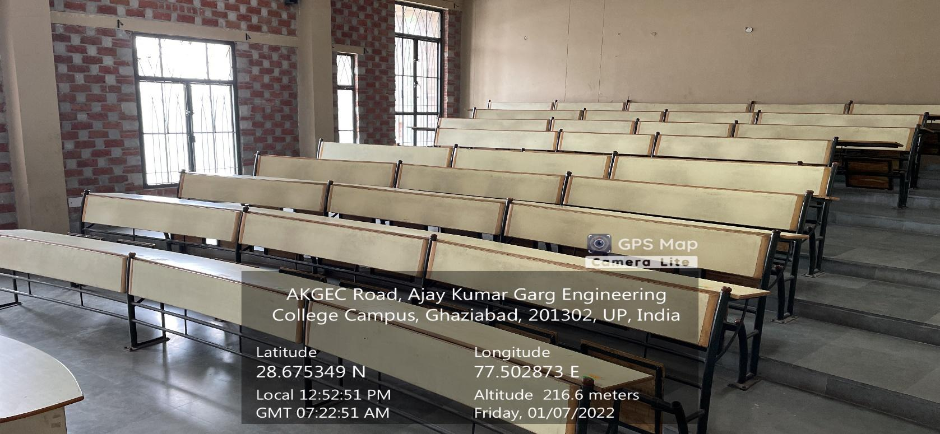**CL-13**

**(CS&IT BLOCK, FIRST FLOOR)**

**(Available Facilities: Green Board, Smart board, Wi-Fi, Sound System)**

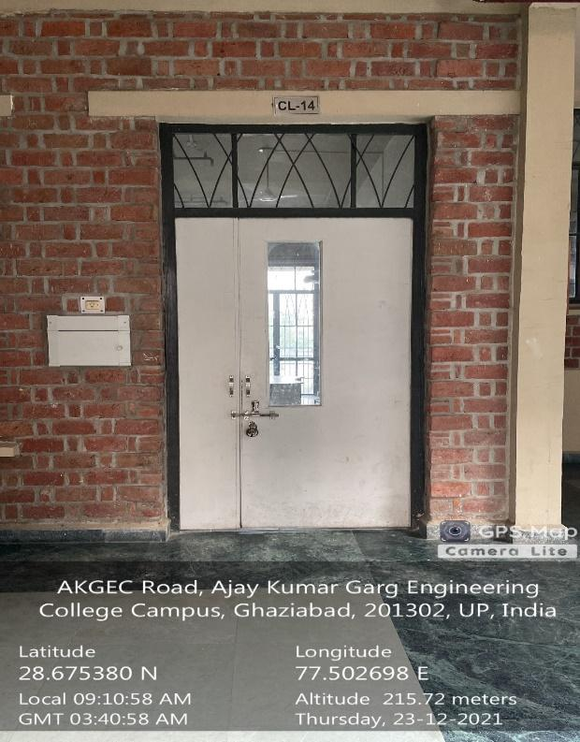

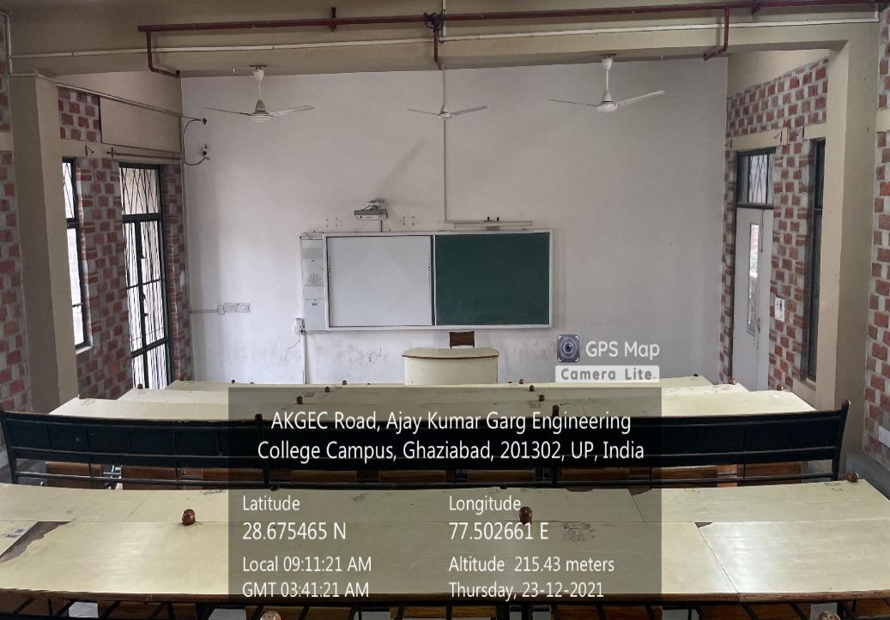

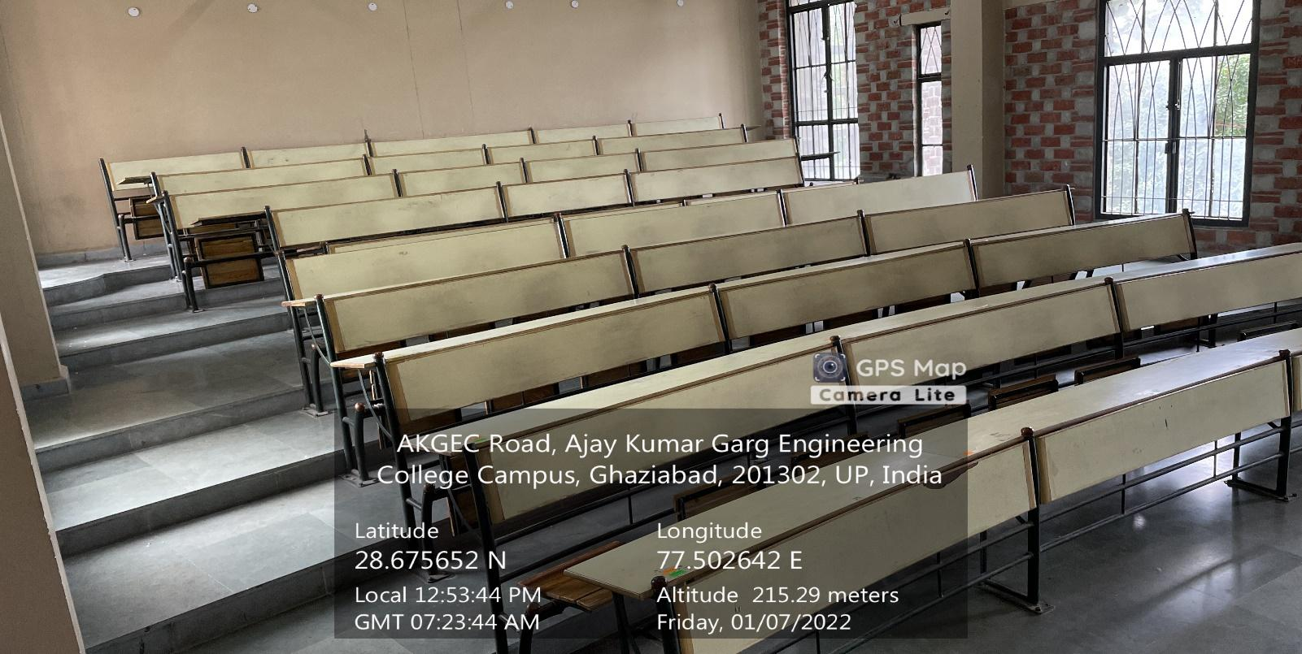**CL-14**

**(CS&IT BLOCK, FIRST FLOOR)**

**(Available Facilities: Green Board, Smart board, Wi-Fi, Sound System)**

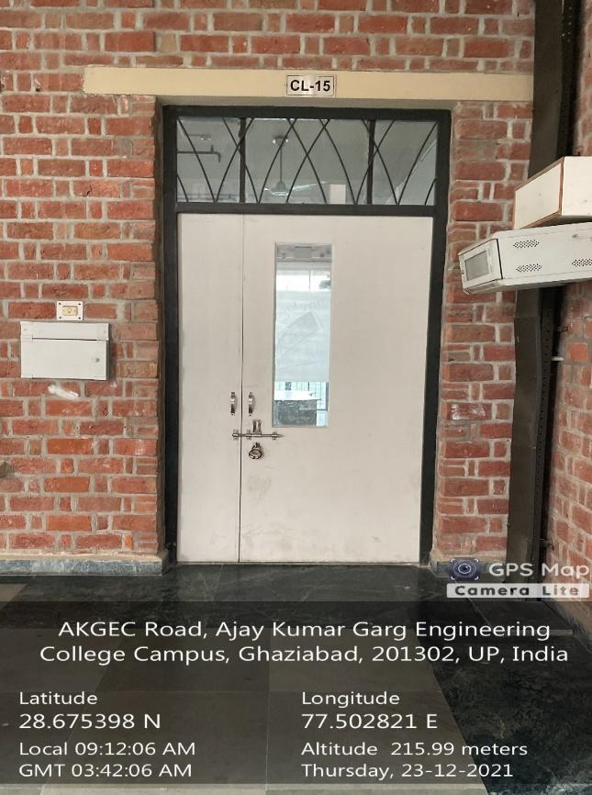 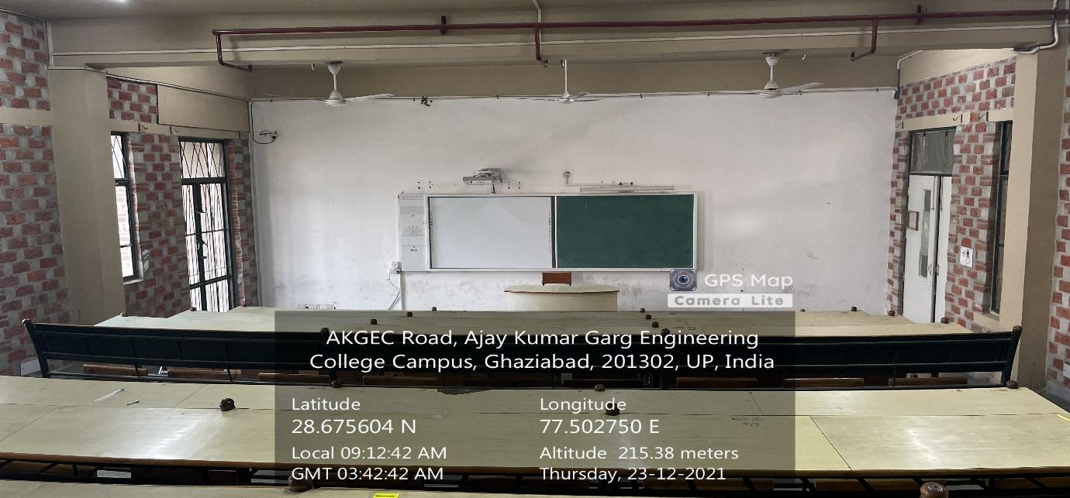

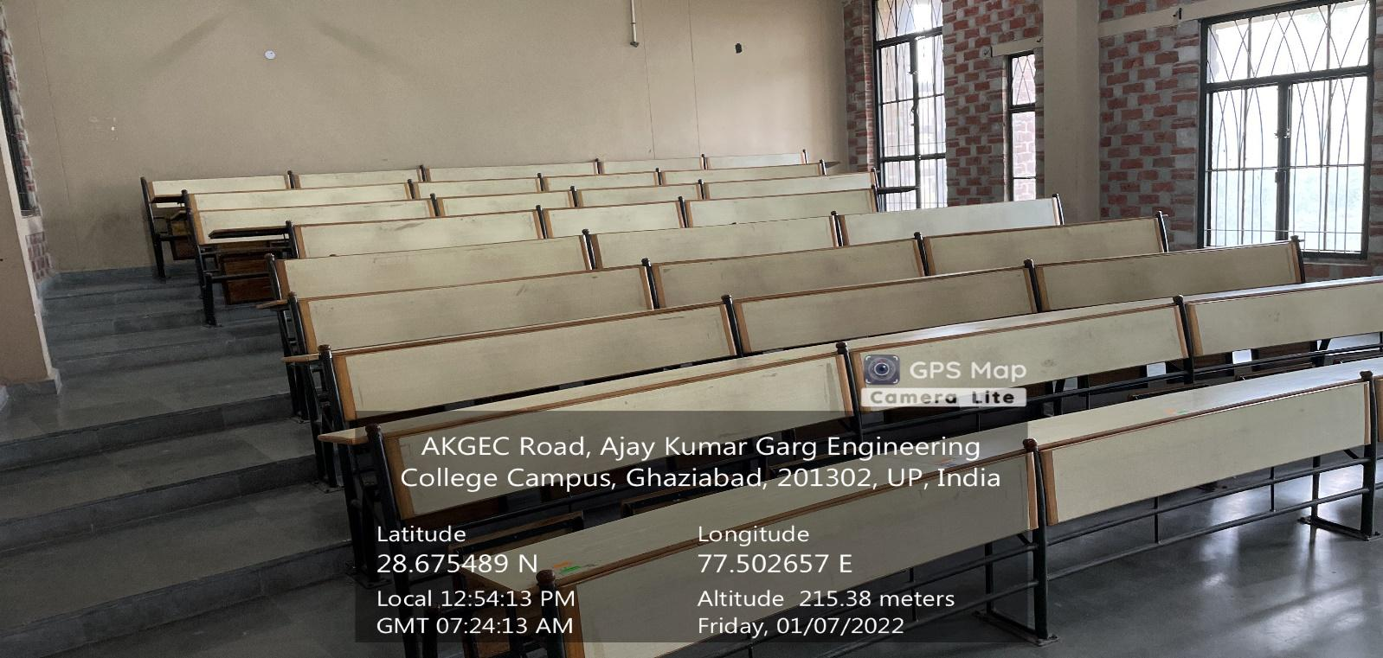

**CL-15**

**(CS&IT BLOCK, FIRST FLOOR)**

**(Available Facilities: Green Board, Smart board, Wi-Fi, Sound System)**

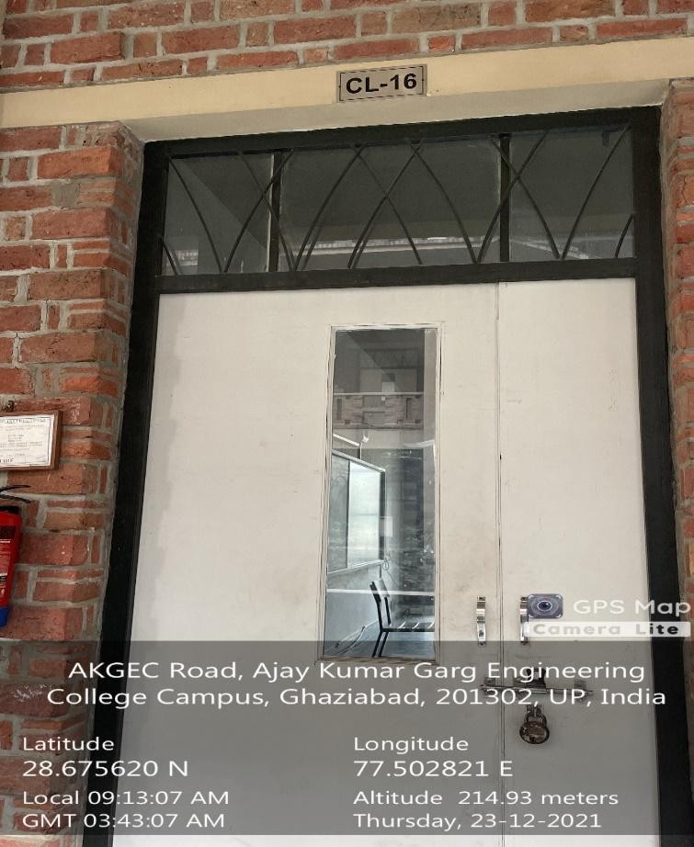 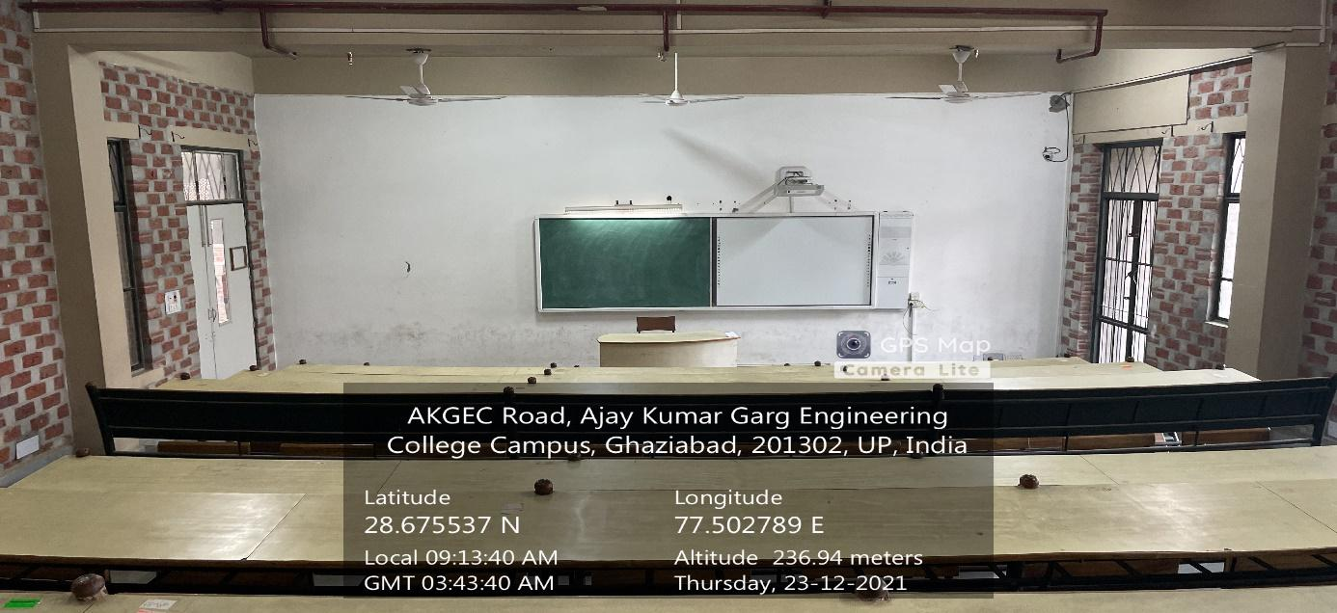

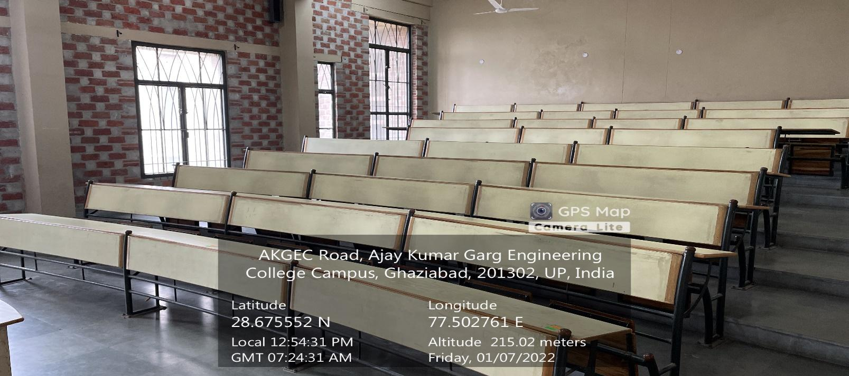**CL-16**

**(CS&IT BLOCK, FIRST FLOOR)**

**(Available Facilities: Green Board, Smart board, Wi-Fi, Sound System)**

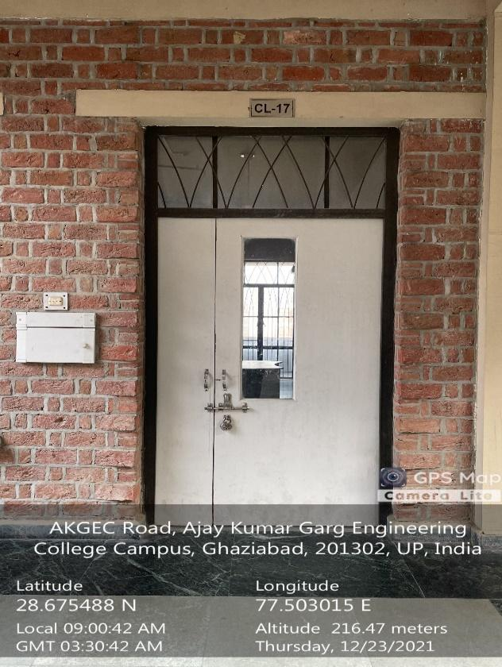 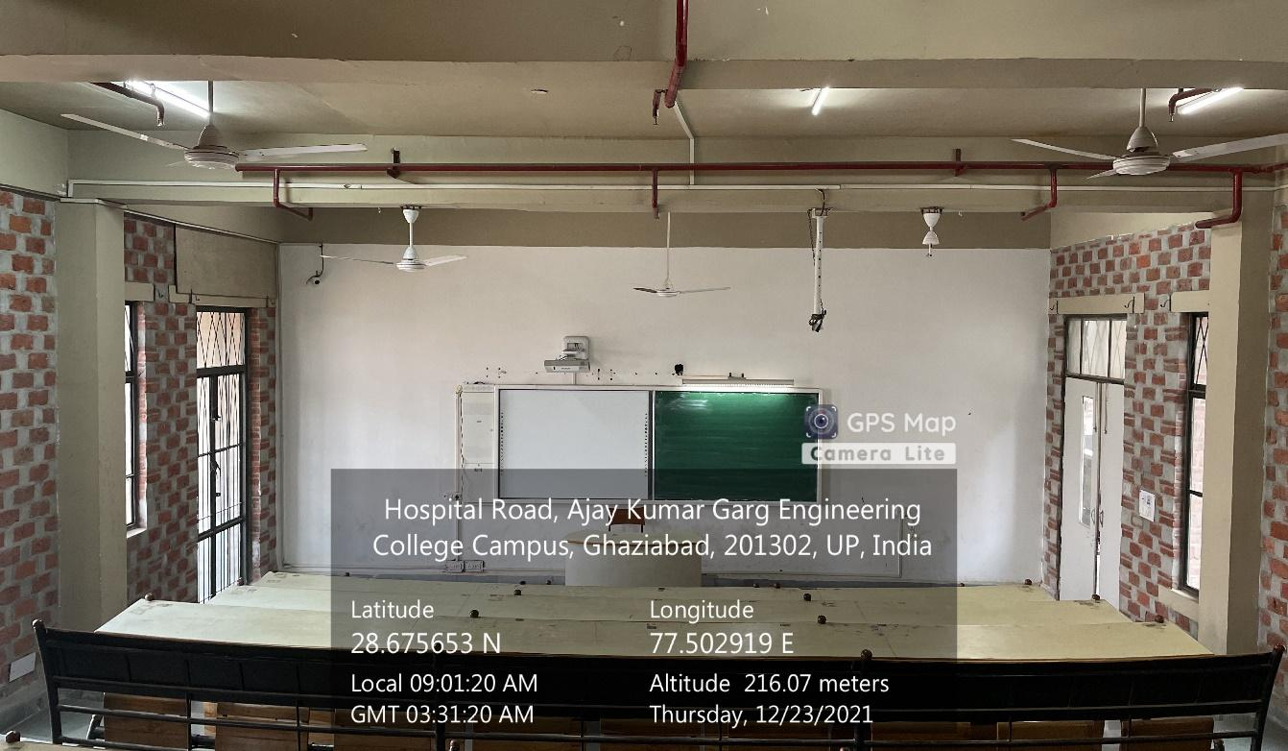

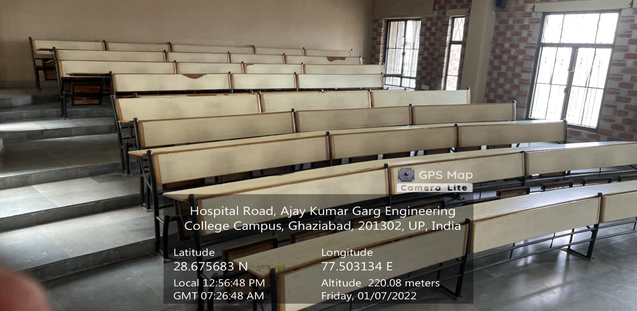**CL-17**

**(CS&IT BLOCK, FIRST FLOOR)**

**(Available Facilities: Green Board, Smart board, Wi-Fi, Sound System)**

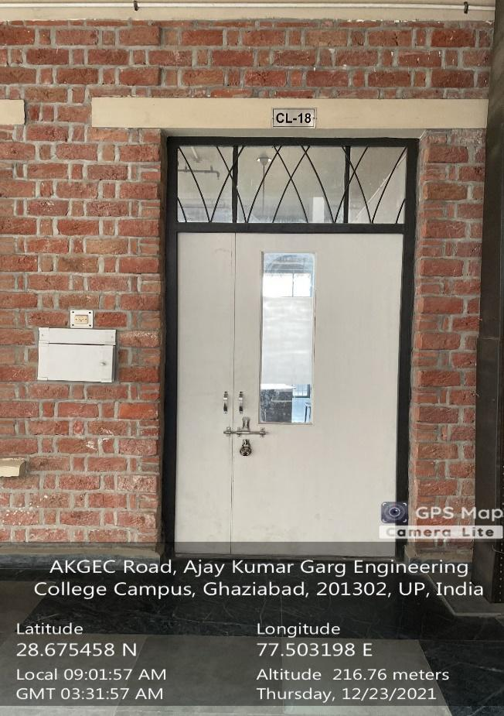 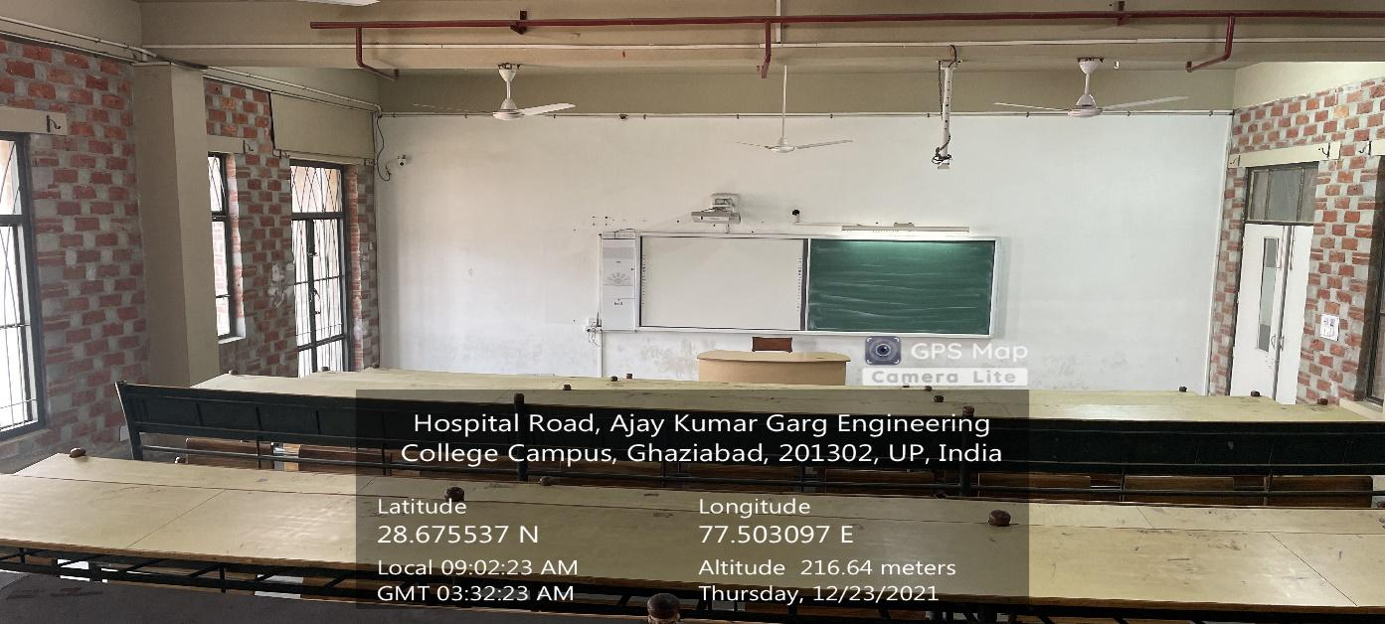

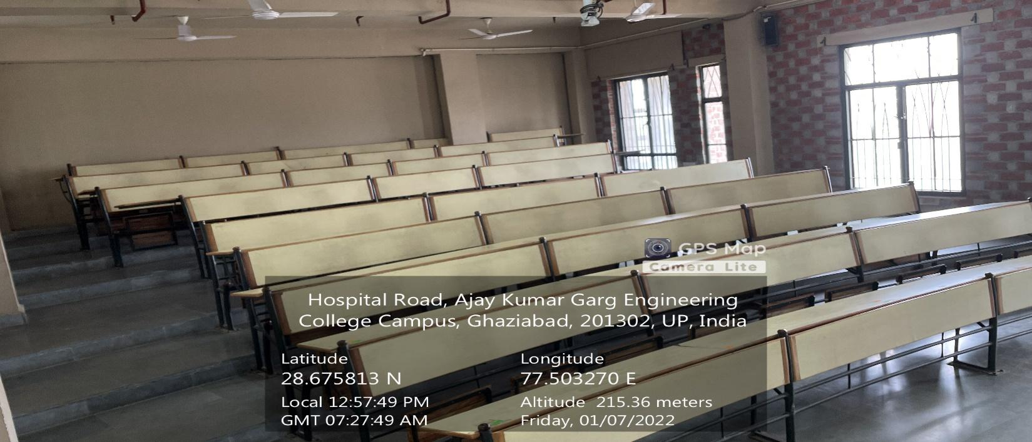**CL-18**

**(CS&IT BLOCK, SECOND FLOOR)**

**(Available Facilities: Green Board, Smart board, Wi-Fi, Sound System)**

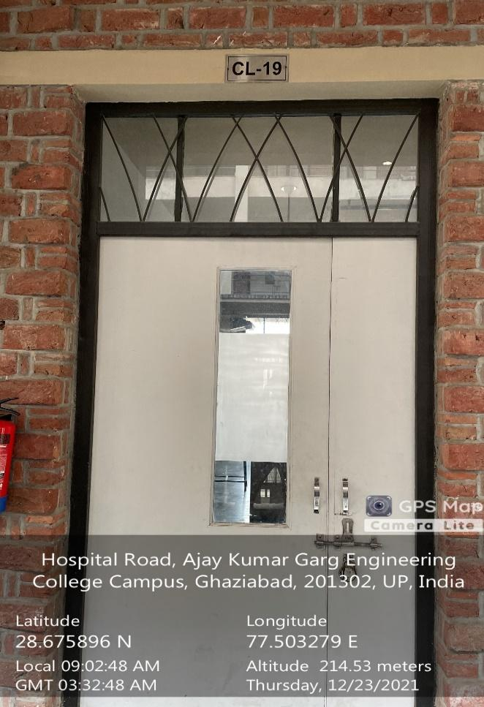 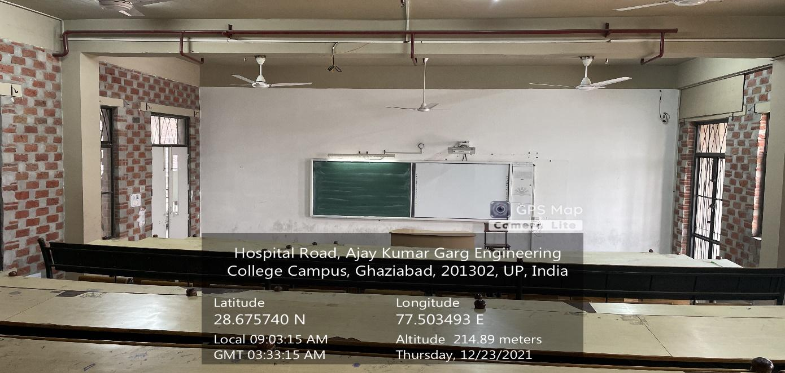

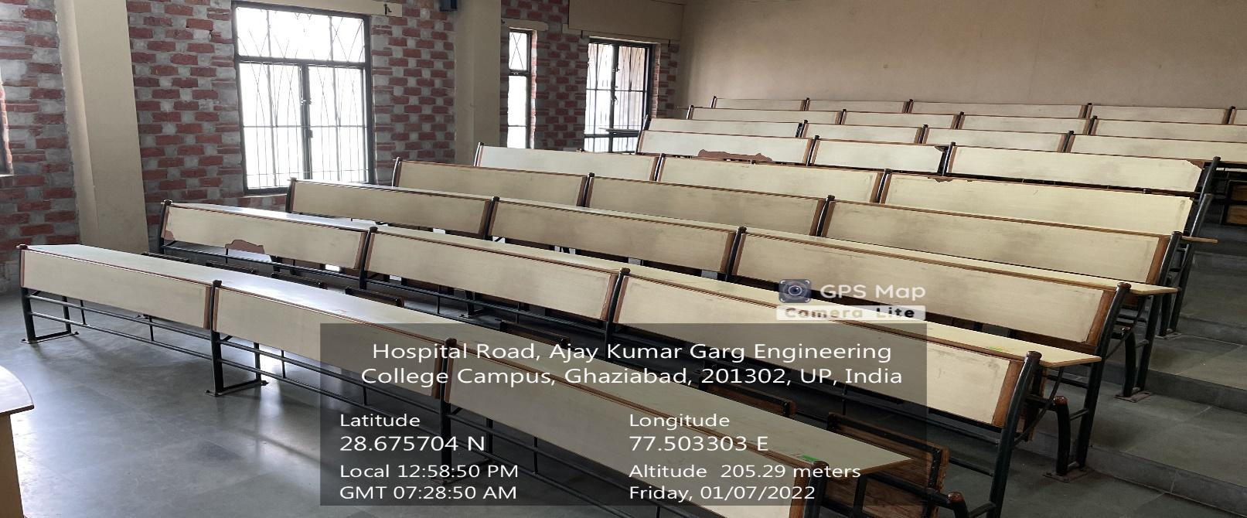

**CL-19**

**(CS&IT BLOCK, SECOND FLOOR)**

**(Available Facilities: Green Board, Smart board, Wi-Fi, Sound System)**

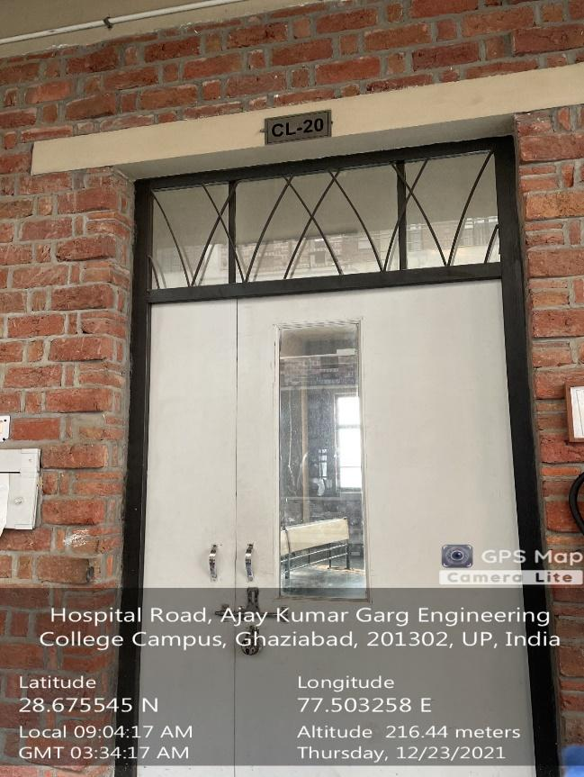 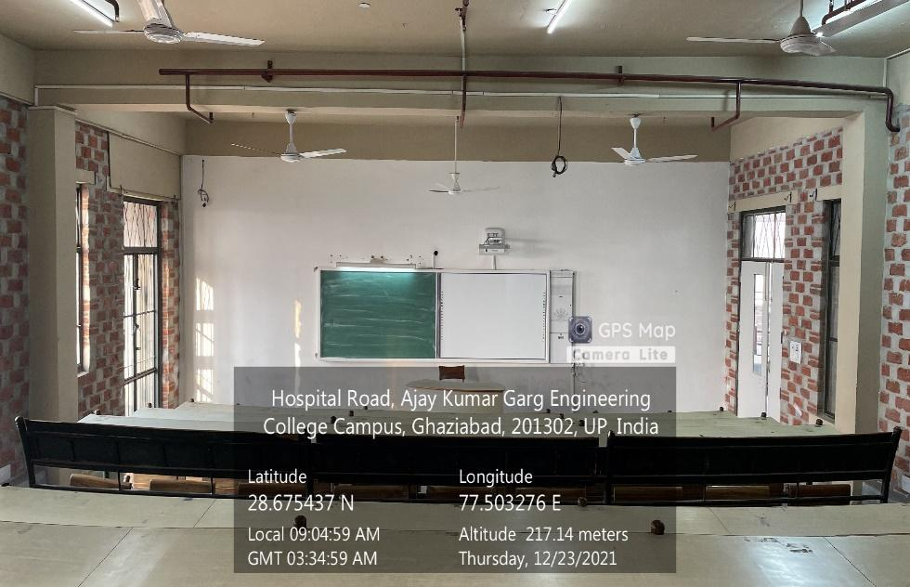

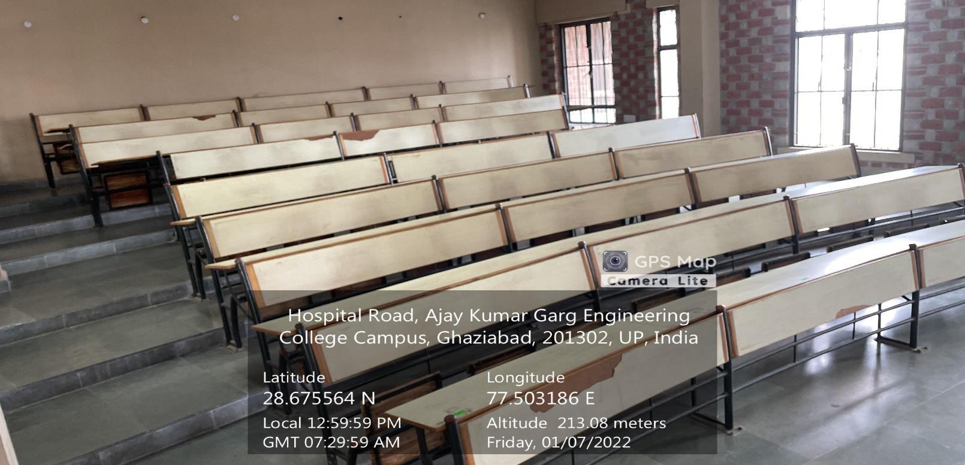**CL-20**

**(CS&IT BLOCK, SECOND FLOOR)**

**(Available Facilities: Green Board, Smart board, Wi-Fi, Sound System)**

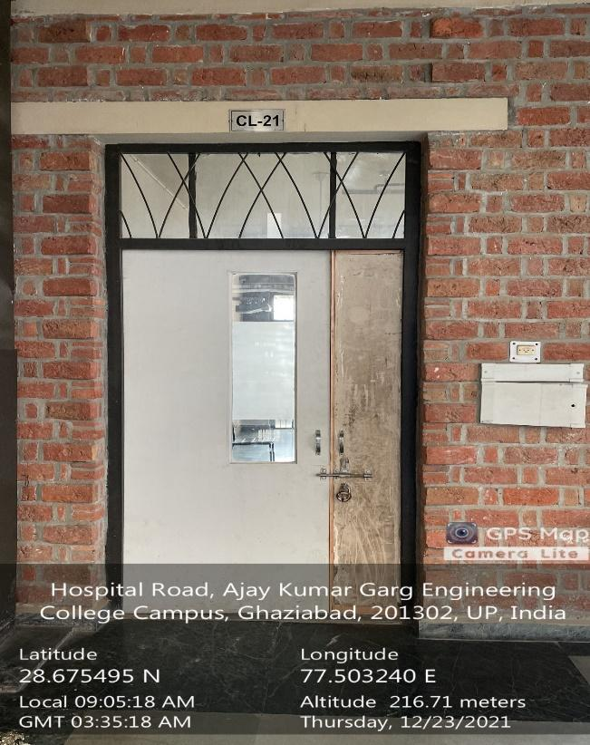 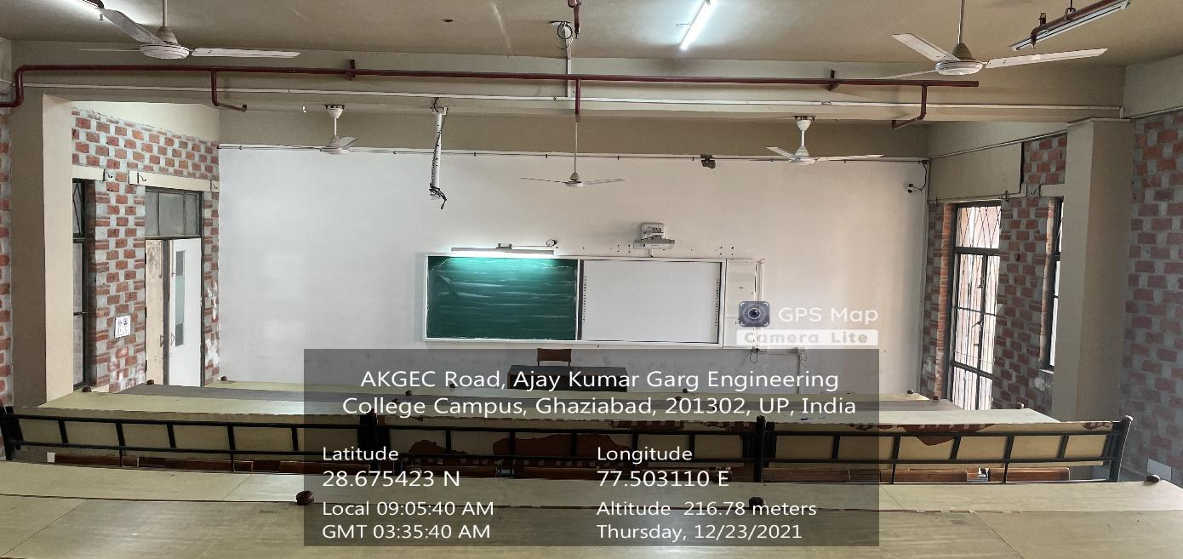

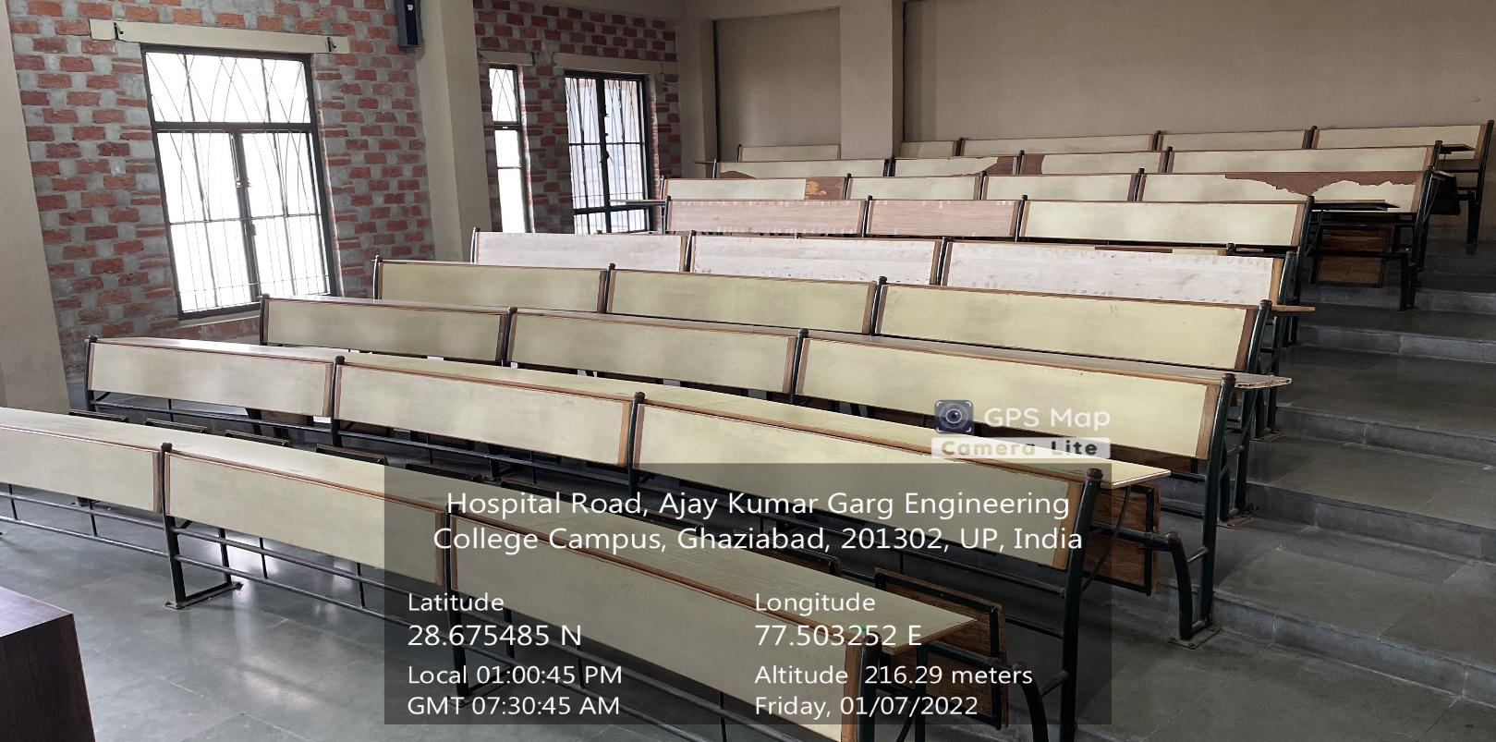**CL-21**

**(CS&IT BLOCK, SECOND FLOOR)**

**(Available Facilities: Green Board, Smart board, Wi-Fi, Sound System)**

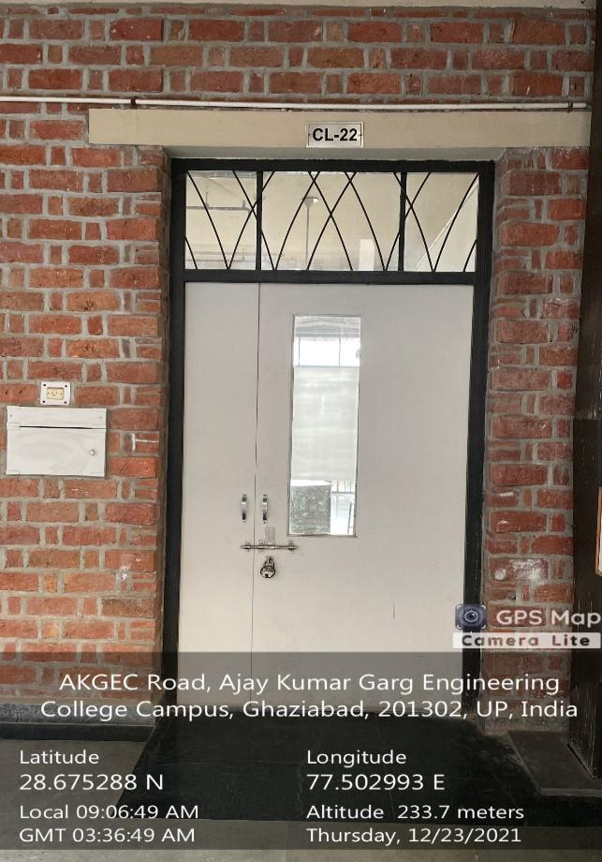 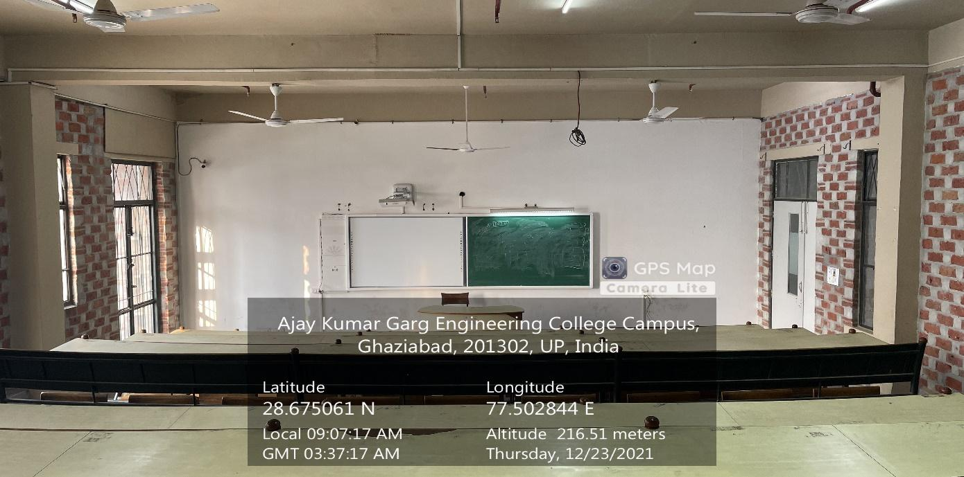

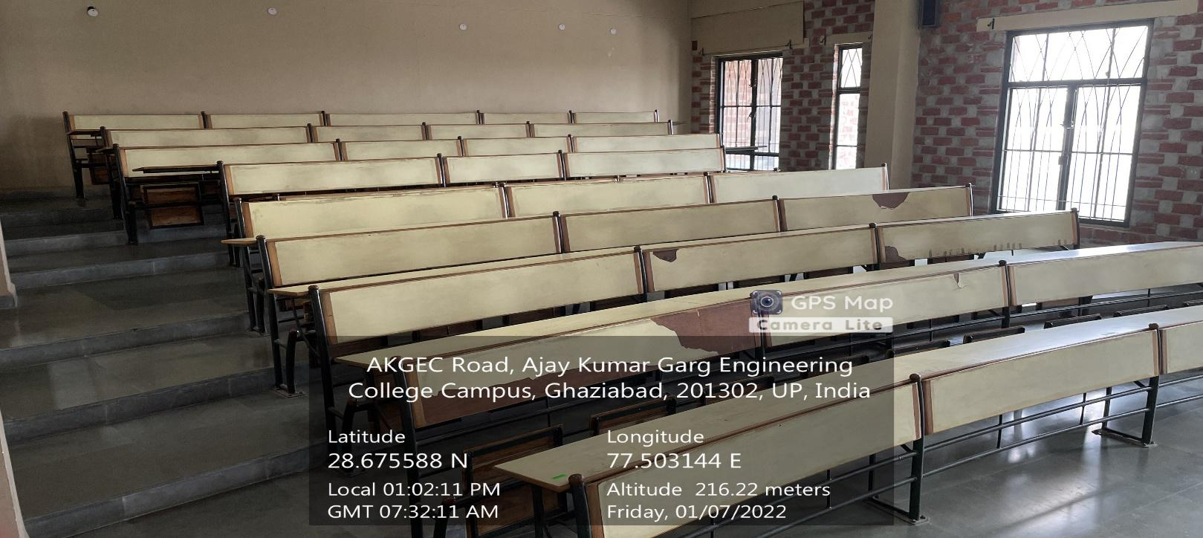**CL-22**

**(CS&IT BLOCK, SECOND FLOOR)**

**(Available Facilities: Green Board, Smart board, Wi-Fi, Sound System)**

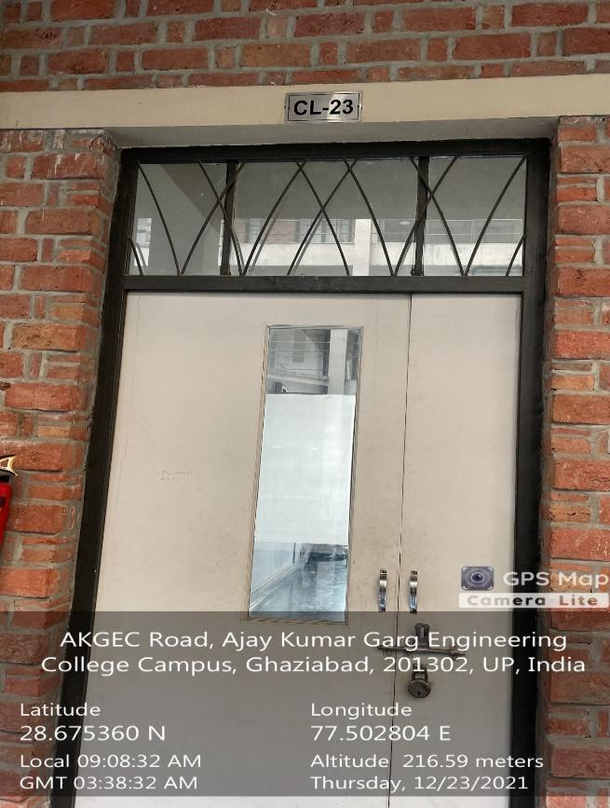 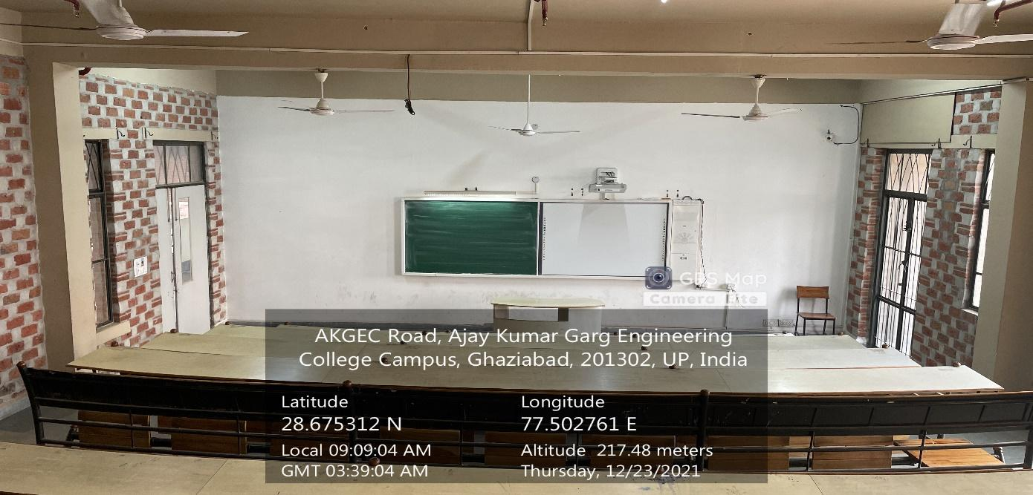

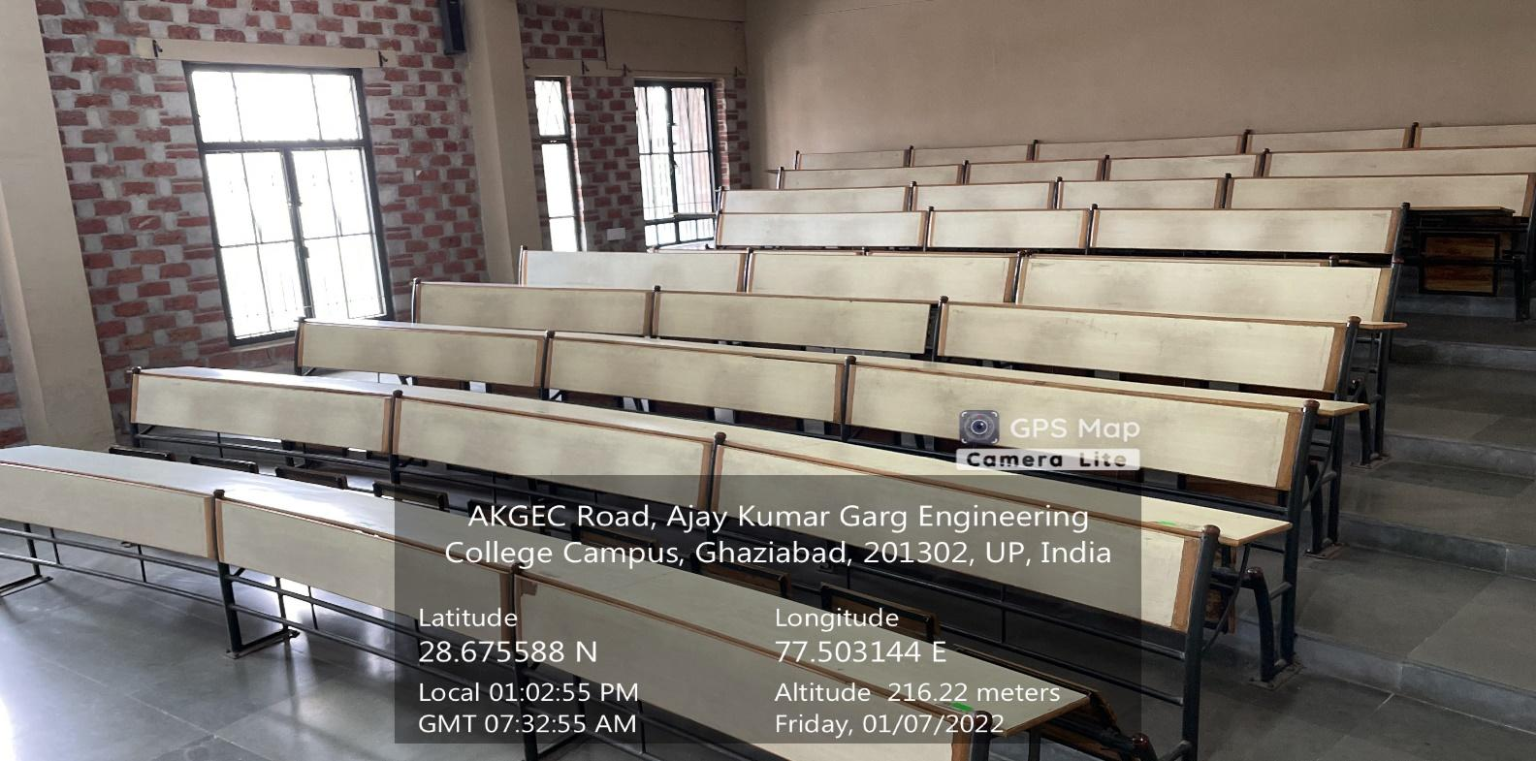

**CL-23**

**(CS&IT BLOCK, SECOND FLOOR)**

**(Available Facilities: Green Board, Smart board, Wi-Fi, Sound System)**

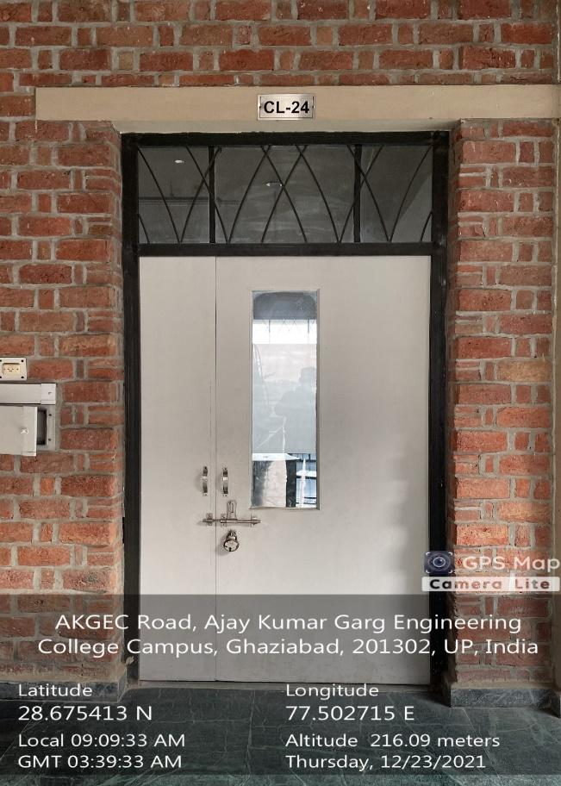 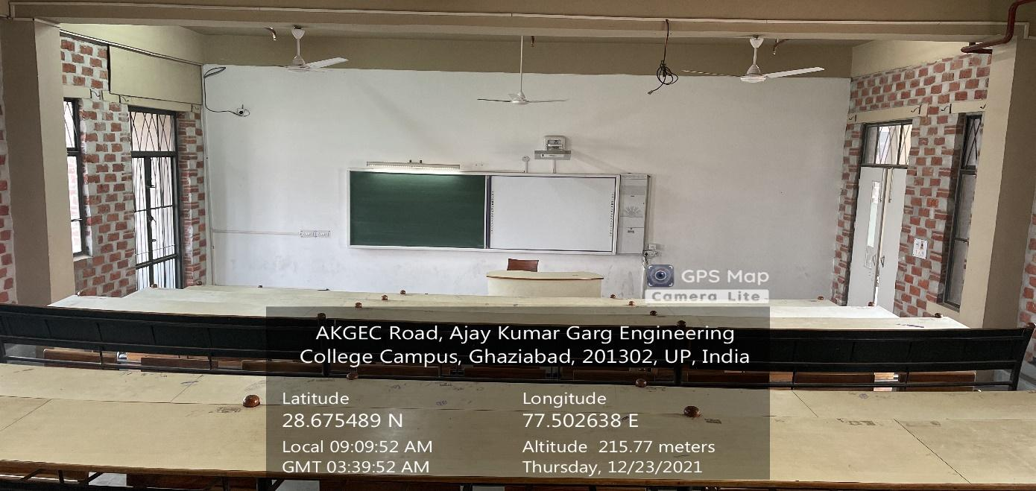

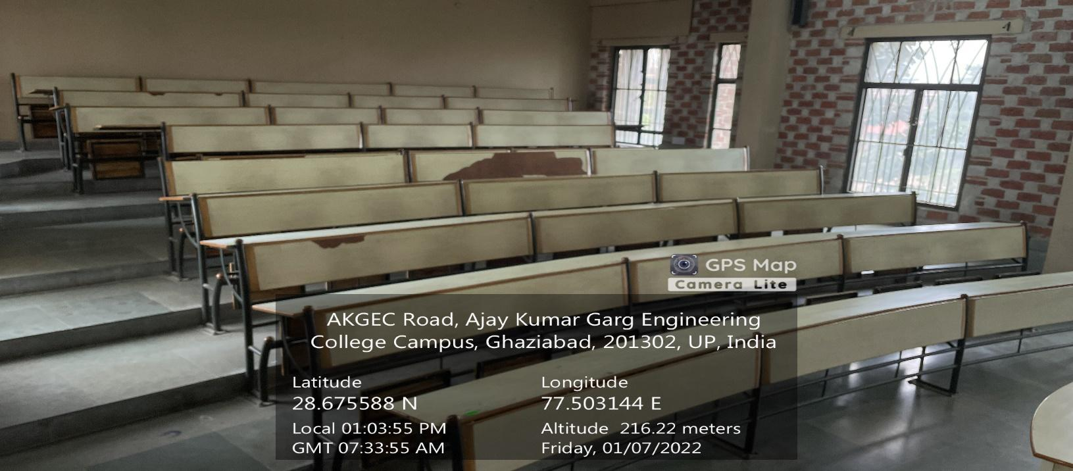**CL-24**

**(CS&IT BLOCK, SECOND FLOOR)**

**(Available Facilities: Green Board, Smart board, Wi-Fi, Sound System)**

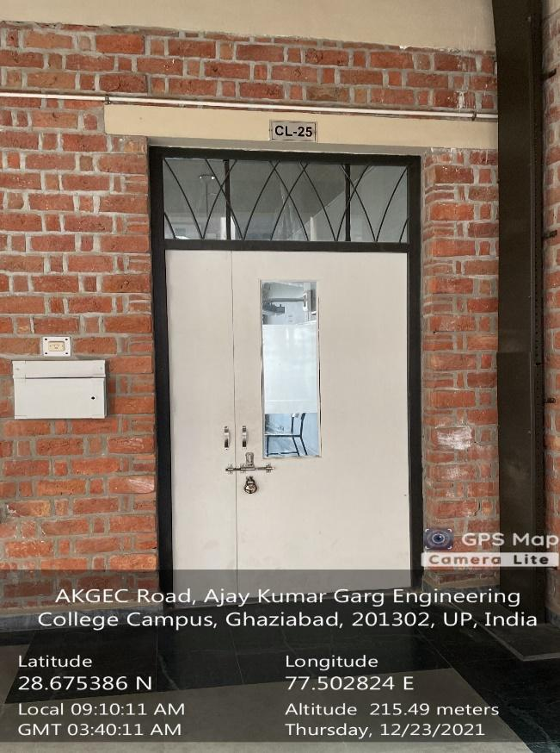 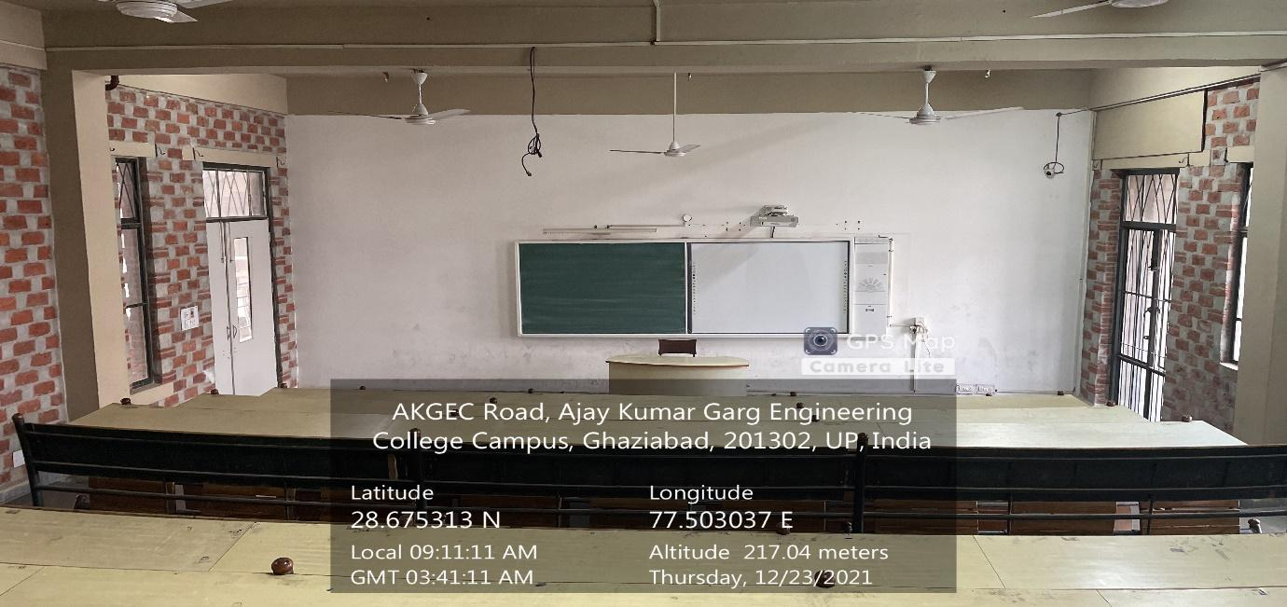

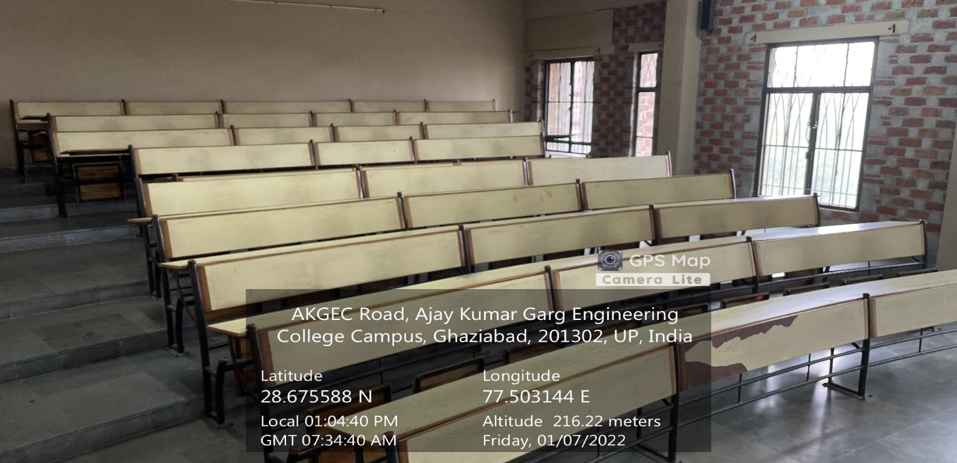**CL-25**

**(CS&IT BLOCK, SECOND FLOOR)**

**(Available Facilities: Green Board, Smart board, Wi-Fi, Sound System)**

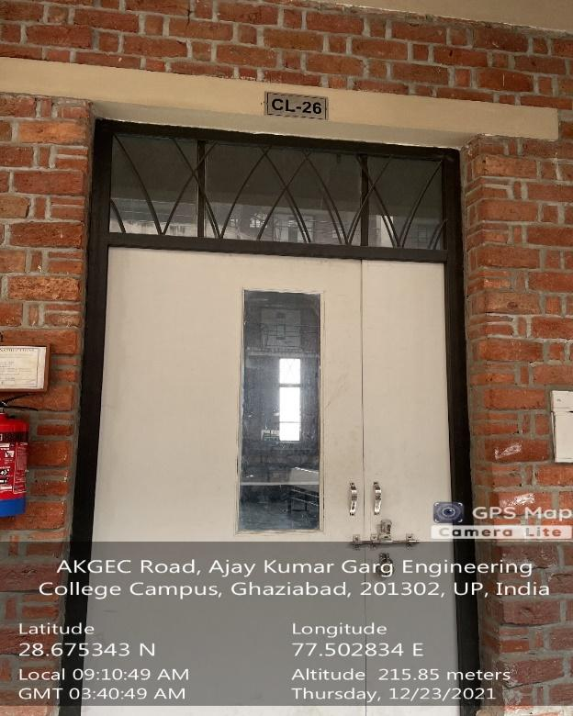 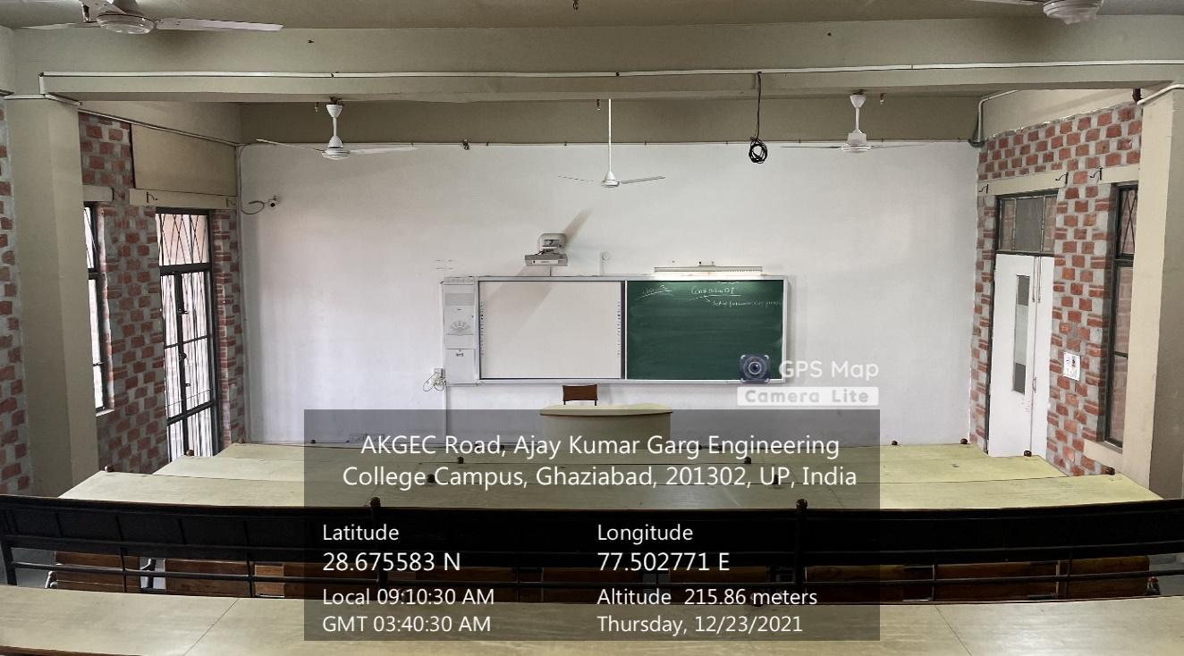

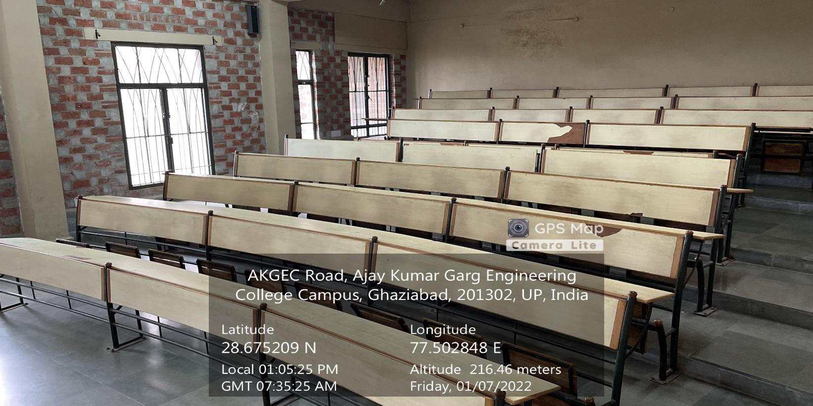**CL-26**

**(CS&IT BLOCK, SECOND FLOOR)**

**(Available Facilities: Green Board, Smart board, Wi-Fi, Sound System)**

**CS&IT**

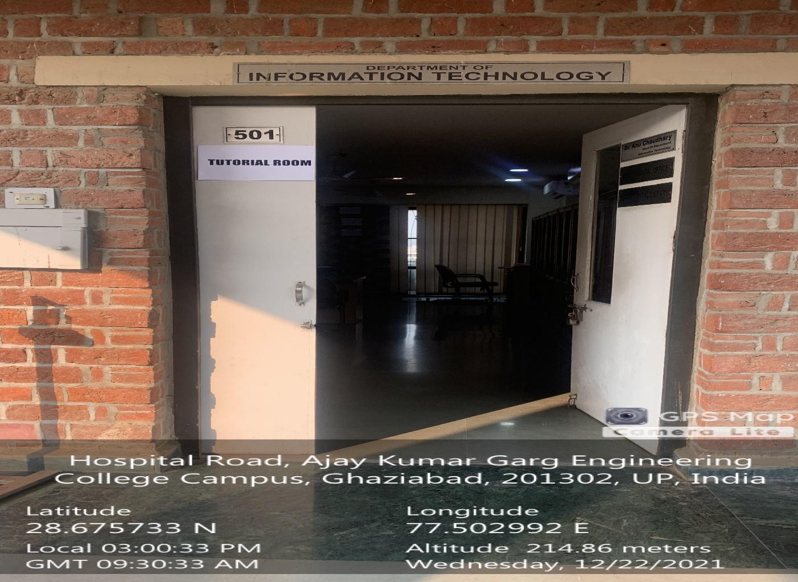

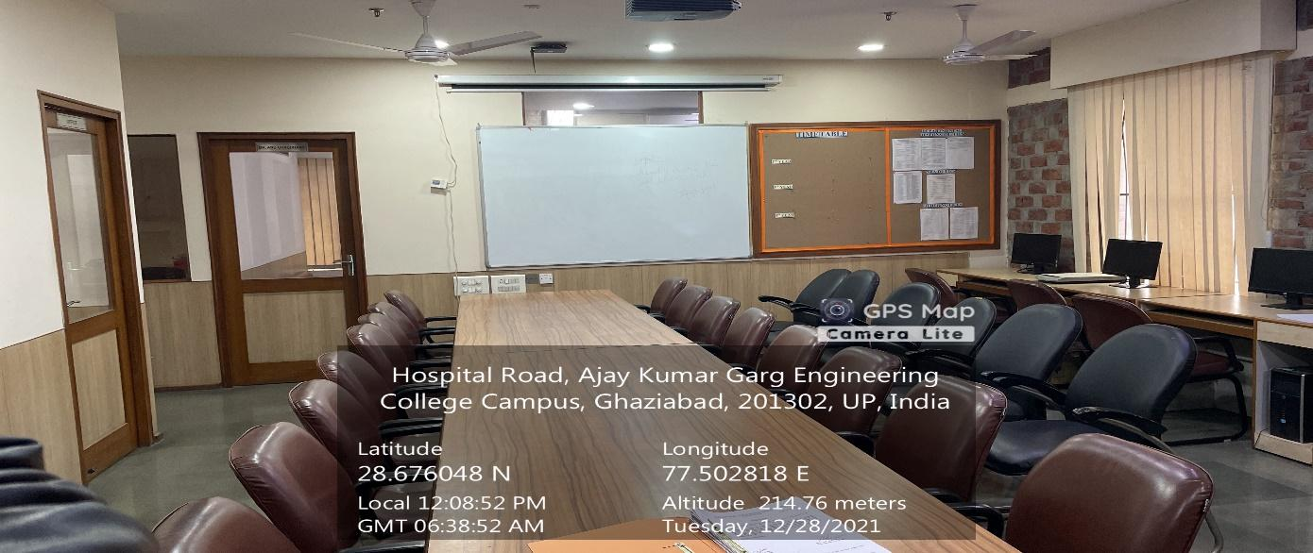

**501-TUTORIAL**

**(CS&IT Block, Fifth Floor)**

**(Available Facilities: Smart board, Wi-Fi, Sound System)**

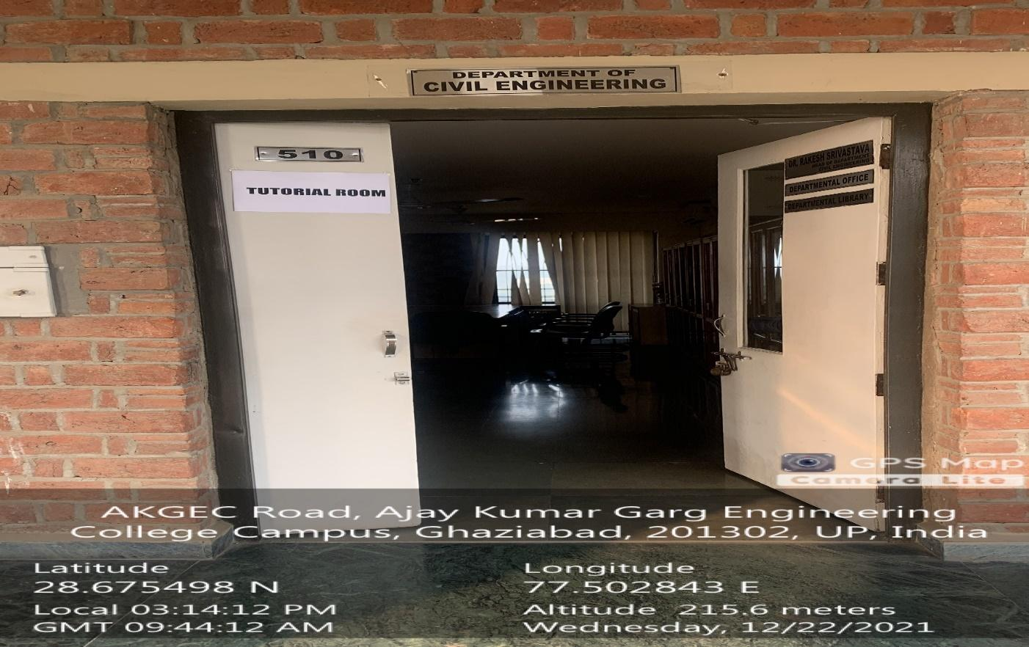

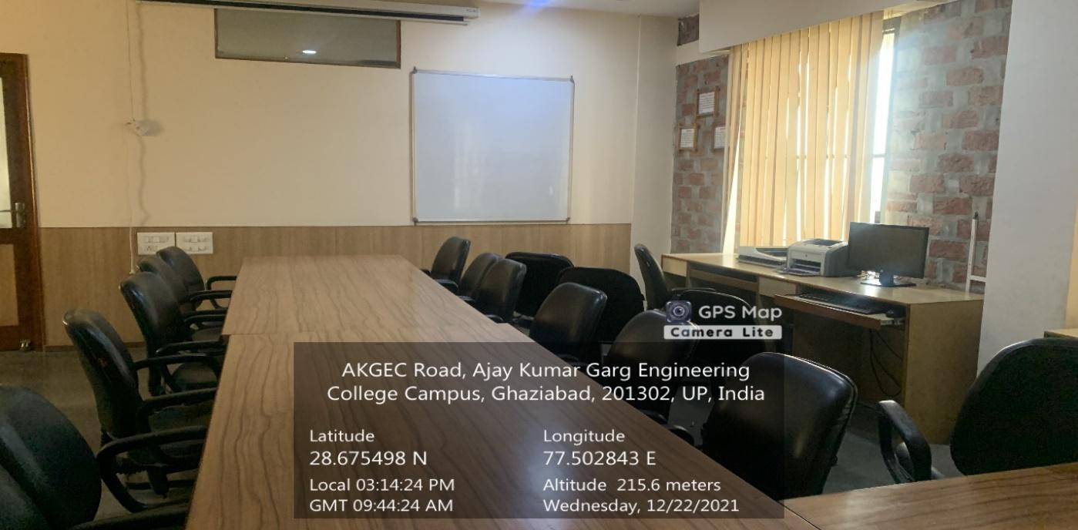

**510-TUTORIAL**

**(CS&IT Block, Fifth Floor)**

**(Available Facilities: Smart board, Wi-Fi, Sound System)**

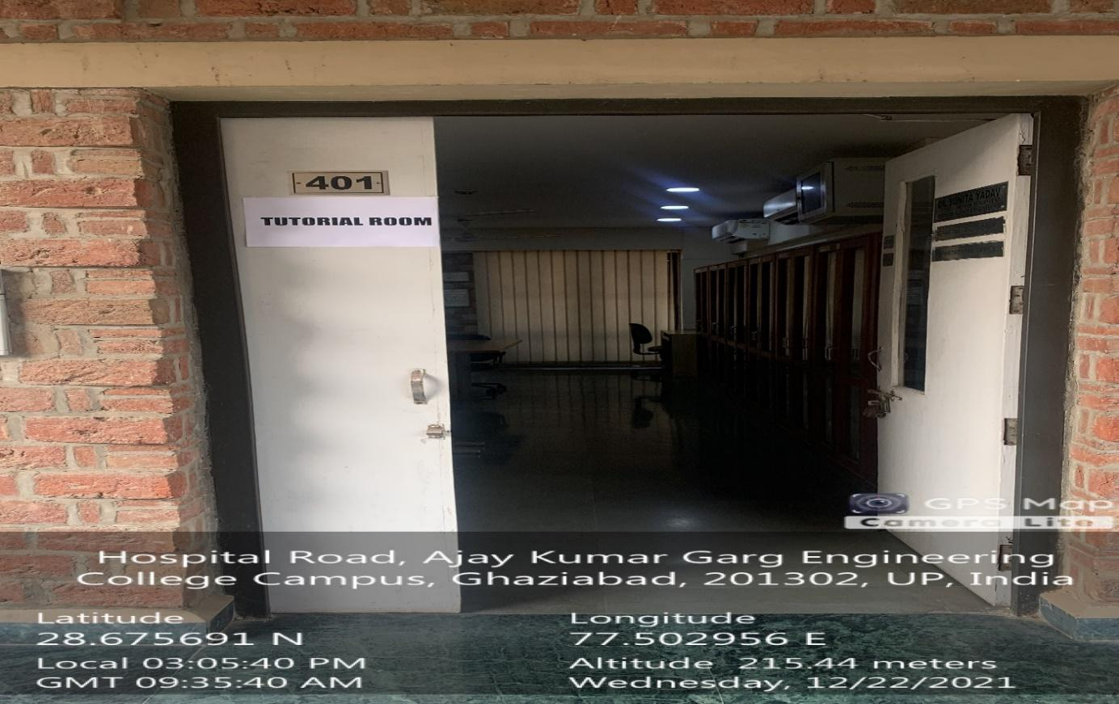

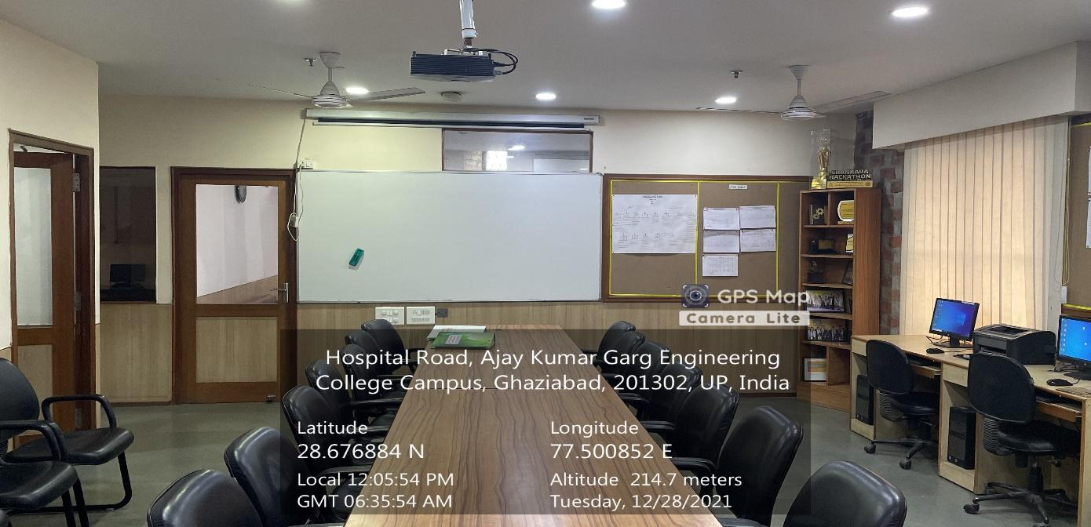

**401-TUTORIAL**

**(CS&IT Block, Fourth Floor)**

**(Available Facilities: Smart board, Wi-Fi, Sound System)**

**`**